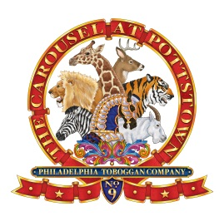
2017 Carousel of Flavor Merchant Form
The Carousel at Pottstown is proud to announce our 14th annual “Carousel of Flavor” on Sunday, September 24, 2017, from Noon to 4:00 PM.
This event has become the premier food festival in the area, welcoming restaurants and food trucks from all around.
Along with food, beverages (including beer and wine), music, and fun, an Arts and Crafts area is set up on High Street in downtown Pottstown. This year, we are welcoming businesses to participate as well.
We invite you to take part in this wonderful event! As usual, thousands of patrons will be on hand creating an ideal setting for selling your wares or your business.
To participate, please complete this form and send it along with the $25 participation fee to:
The Carousel at Pottstown
30 W. King St.
Pottstown, PA. 19464 Please make your check payable to: The Carousel at Pottstown.

_____________________________________ _____________________________________
Name Business Name

_____________________________________ _______________________________________
Street or PO Box Business Description

_____________________________________ _______________________________________
City, State and Zip Code Phone Number

_____________________________________
E-mail Address

If you have questions, please call Jim Bauer at 484-366-5749 or Bev Reber at 610-608-7772.
Please arrive by 11:00 AM on Sunday September 24. We do not supply tents, tables or electricity.
Carousel at Pottstown, Inc. is §501(c)(3) nonprofit corporation subject to certain regulations and limitations. We can gladly welcome crafters and retail and service businesses at the Carousel of Flavor, but the involvement of any organization or person, or any activity thereof, which could jeopardize our tax-exempt status will be strictly prohibited. Carousel at Pottstown, Inc. reserves the right to deny participation by or activity of any person or group which does not, in the opinion of the Carousel at Pottstown, further its mission, including political or religious organizations.

