Mark Brooks – Vice President
markbrooks@esiccorp.com

Benefit Services and Capabilities

ESIC COnsulting SERVICES

With topics ranging from health care reform to health savings accounts, Health Plan Partners has the resources to help you stay on top of benefits trends and to keep your organization running more efficiently. This booklet provides an overview of our content offerings with sample titles organized by topic.

A Full Client Experience 1
Health Care Reform 3
Employer Education 4
Health Care Reform Calculators 4
Employee Communications 4
Notices and Disclosures 4
Presentations 4
Plan Design 6
Benchmark Surveys & Statistics 7
Plan Design Strategies 7
Compliance 8
Federal Legislation & Compliance 9
State-specific Legislation & Compliance 9
Human Resources 11
Enrollment Tools 12
HR Tools 12
Educational Materials 12
Succeed With Social Media 12
Workplace Wellness 14
Wellness Resources 15
Employee Health & Wellness 15
Employee Consumerism Education 15
Benefits Communication 17
Benefits Insights 18
Employer Newsletters 18
Total Compensation Statements 18
Employee Newsletters 19
Benefits Announcements and Educational Material 19
Retirement Communications 19
How Do We Measure Up 21

A Full Client Experience
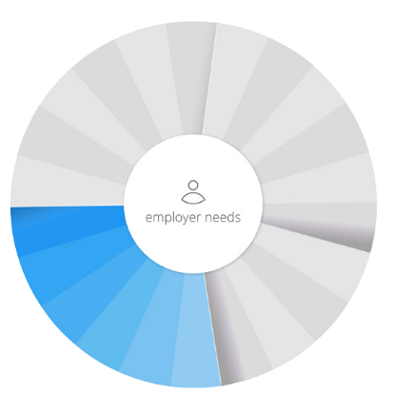
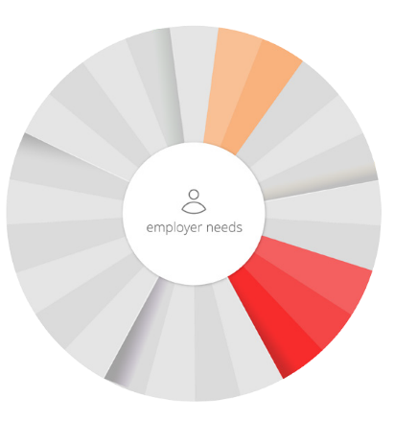
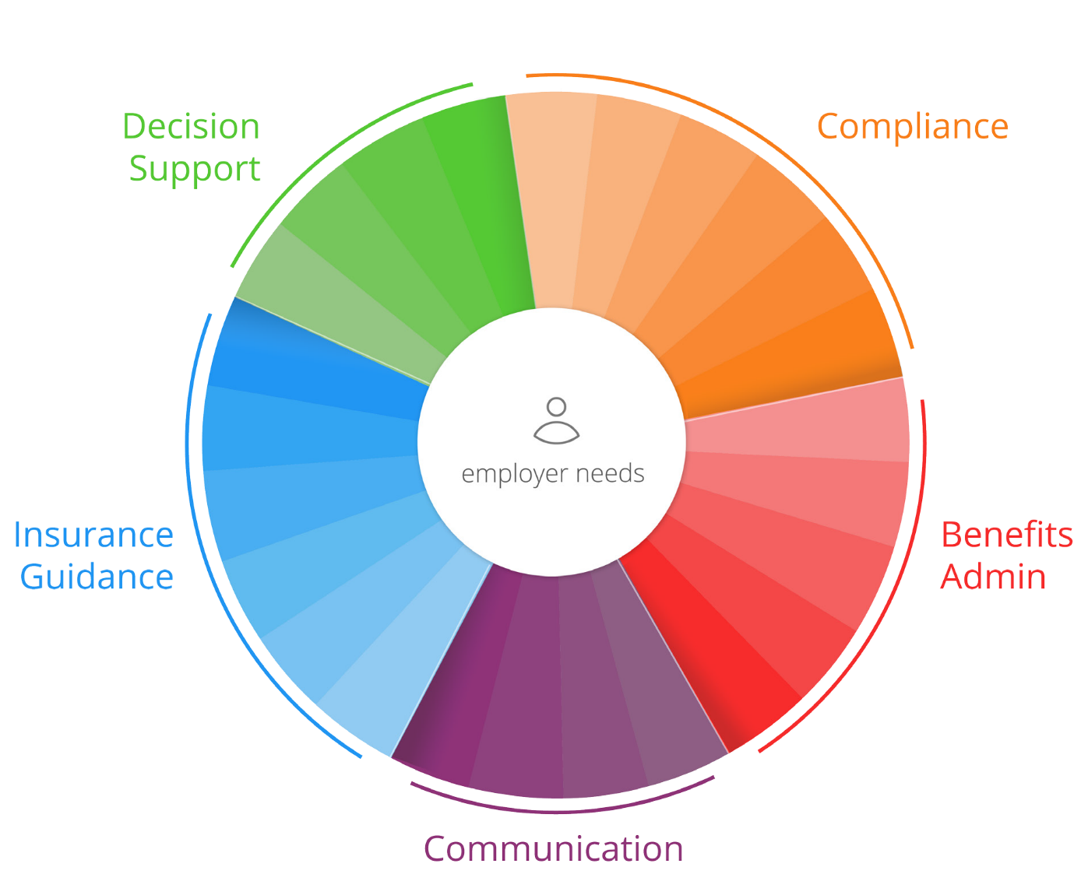
Typical
Services
From Brokers
Break away from the mold of the traditional broker. The average broker meets your basics needs when it comes to claims, plans and renewal negotiation. What about open enrollment? New legislation?
From Technology Companies
New tech giants can be focused on curing the pains of HR such as benefits administration and small compliance issues, but lack the personal touch and insurance expertise that an independent broker like us provides.
ACA & DOL Compliance/Tools
6055/6056 Reporting 1094/1095 Filing
HR Assistance
Employee Benefits Statements
Employee Handbook
Quote Plans
Claims & Billing Assistance Negotiate Renewal
Plan Comparison
Coverage & Policy Expertise Application Submission
Health & Wellness Information
Healthy Lifestyles/Fitness Programs Employee Newsletters & Videos Employee Benefits Communications
From compliance to communication, we provide a full spectrum of solutions for you and your company.
We understand the challenges today’s employers face and know you’re asked to take on more than ever.
Expect more from a broker- expect our full spectrum of solutions.
Plan Design & Selection Support
Plan Disruption Analysis
Employee Retention Strategies
Plan Benchmark Analysis
Online Enrollment
On-boarding/Off-boarding Assistance Plan Design Decision Support
HR Intranet

32% of business plans audited by the DOL received fines of
over $10,000.
No need to worry- you can rest easy with our regular compliance newsletters, articles, action plans & support keeping you up-to-date and in the know.

89% of employees expect decision making tools
during open enrollment.
Our decision support tools match your industry, region and company size from a plan design and perspective. We’ll provide Medical & Rx Analytics, Employee Retention plans and Open Enrollment assistance specified to your business needs and goals.

54% of employees say selecting a health plan is more complicated than
solving a Rubik’s cube.
Take the guess work out of plan selection and simplify your day-to-day with our streamlined online enrollment, vacation tracking and more on a customized intranet site.

An inactive employee can cost you up to $1,500 extra in health
costs per year; only 34% of employees were aware of any wellness
plan offered by employers.
Communication is the most important part of any relationship. Let us help you engage and educate your employees by providing Health & Wellness plans, Benefits Guides and numerous safety and awareness materials.

We’re Your Trusted Source.
Get all these services plus the guidance to navigate the complexities of insurance from a partner you can trust.

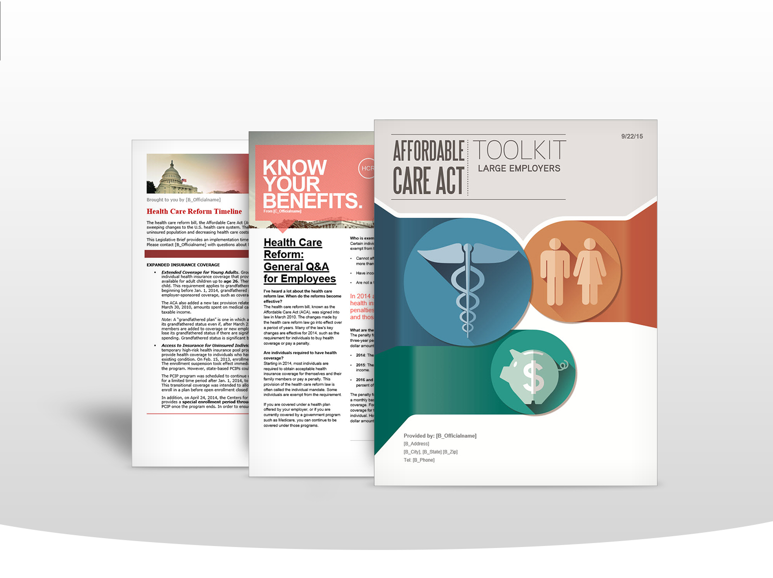
Health Care Reform
With constant changes and regularly released guidance, it’s often difficult to stay up to date on health care reform. We provide timely newsletters, articles and news briefs to help you and your employees stay on top of the most recent legislation.

  - Are you in compliance with health care reform regulations?
  - How do you keep employees aware of changes?
  - Do you have unanswered questions about health care reform?

Employer Education
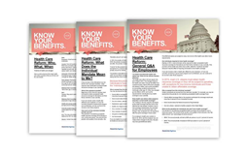
Stay informed with the latest information as health care reform provisions take effect.
- Health Care Reform Toolkits
- The Health Care Reform: 2016 Compliance Checklist

Health Care Reform Calculators
Use sophisticated calculators, to help guide your decisions by modeling the estimated impact health care reform may have on your business.
- Our Health Care Reform Pay or Play Calculator
- The Health Care Reform Large Employer Calculator
- Use the Health Care Reform Full-time Employee Tracker
- The Section 6055 and 6056 Reporting Workbooks save you
- The Affordable Care Act – Cadillac Tax Calculator helps

Employee Communications
Your employees need health care reform communications that are easy to understand.
- Health Care Reform: General Questions and Answers for Employees
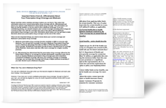
- Health Care Reform: The Who, What and When

Notices and Disclosures
Never go searching for a model notice again. We have dozens of government-issued model notices and disclosures.
- Model Creditable Coverage Disclosure Notice
- Model Notice of Annual Limit Waiver
- Model Notice for Grandfathered Plans

Presentations
Use these comprehensive presentations to educate employees on health care reform legislation.
- Benefits 101: Health Care Reform Presentation
- The Individual Mandate Presentation
- Why Your Eligibility for Employer Health Coverage Can Change – Presentation
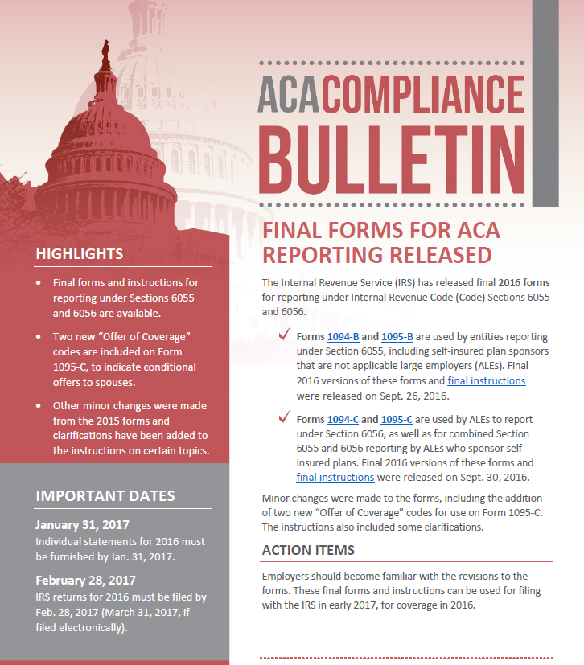

Plan Design
With information on dozens of sample plan designs and timely benchmarking data, we’ll help you find the plan that is right for your employees and your organization’s bottom line.
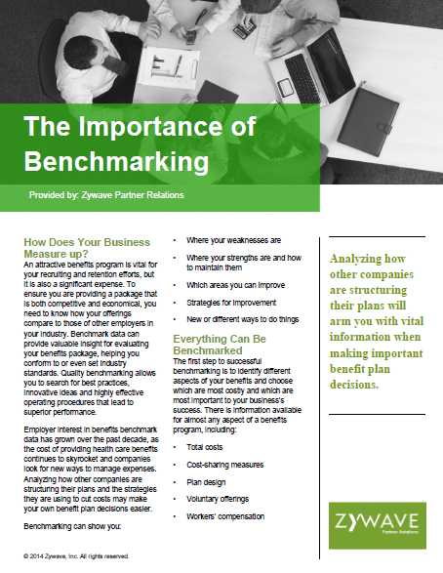
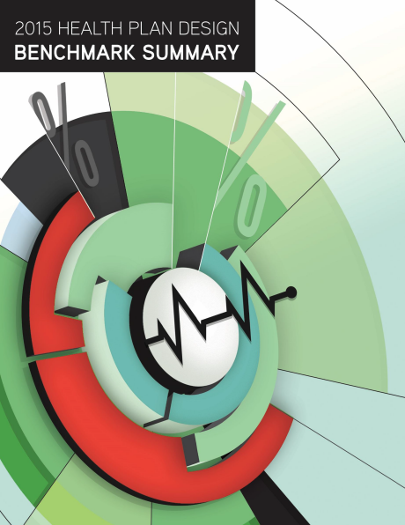
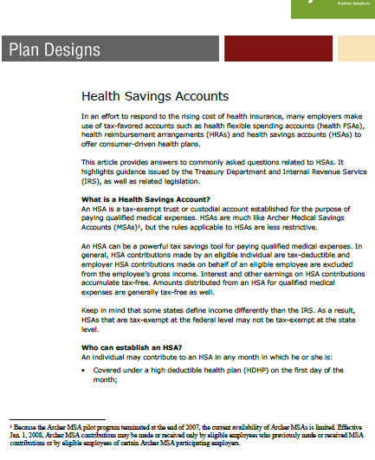

  - How do your benefit offerings compare to other employers in your industry?
  - Benchmarking allows you to anticipate the shifting benefits landscape and evolve before your competition responds.

Benchmark Surveys & Statistics
Stay on top of the latest benefits trends and see how your benefits program compares to those of employers from around the country by using the results of numerous benchmarking surveys.
- 2015 Health Plan Design Benchmark Summary
- We also offer a number of national surveys on topics including health care reform, health plan features, workplace wellness and paid time off benefits.

Plan Design Strategies
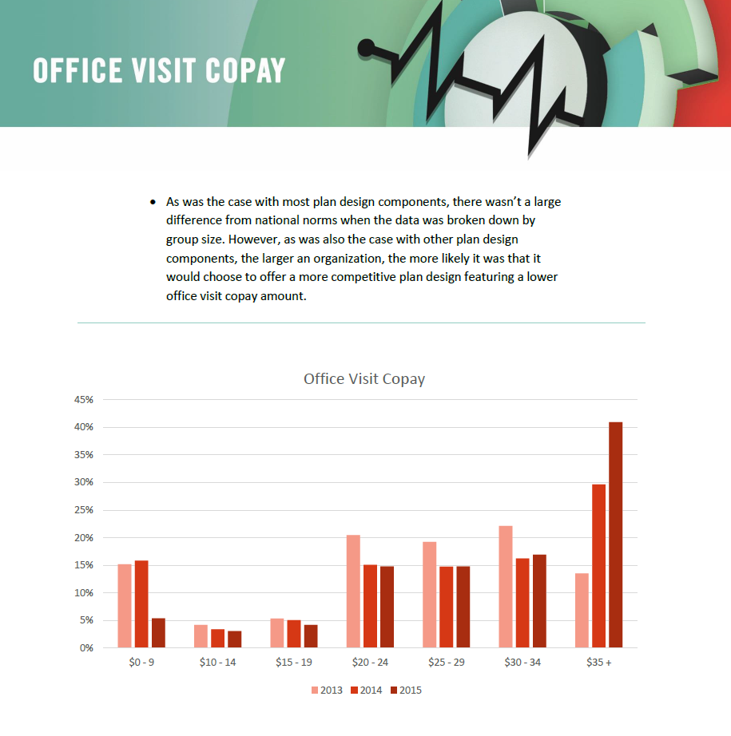
Want to know more about a different plan design? Uncover the details about a benefit plan with one of the many Plan Designs articles we provide.
- Plan Designs: Health Savings Accounts
- Understanding Trend and the Impact on Your Renewal
- Plan Designs: Voluntary Benefits
- Plan Design: The Self-insurance Guide

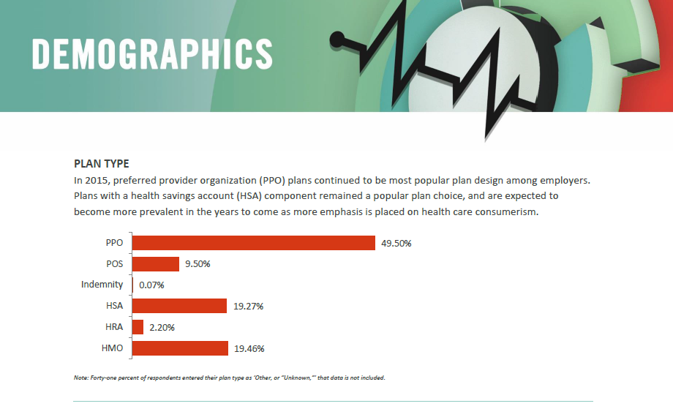

Compliance
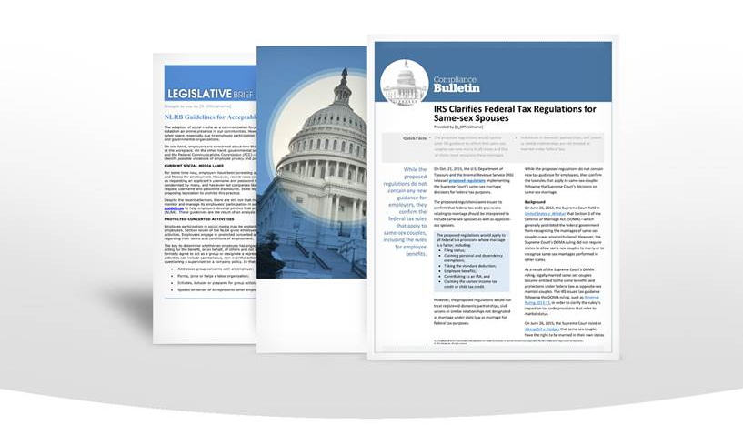
Between changing legislation and health care reform, staying compliant has never been more difficult. Not anymore—we deliver all the legislative information you need. This information is released in a timely manner and reviewed by a team of lawyers to keep you updated and compliant.
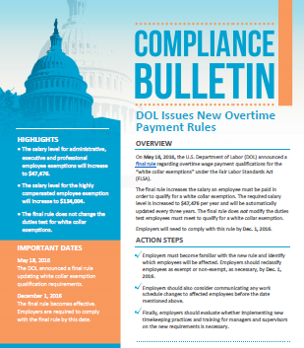

  - Are you compliant with all federal benefit laws, rules and regulations?

  - Do you have access to constantly updated compliance bulletins and guides to help you find answers to your questions?

Federal Legislation & Compliance
Stay up to date with access to valuable information on the ADA, COBRA, CHIPRA, FMLA, HIPAA (including privacy), GINA, Medicare Part D, Mental Health Parity, Section 125, and other federal regulations and employment laws.
- DOL Audit Guide: Employee Benefit Plans
- DOL Model Notice for CHIPRA Premium Assistance Subsidies
- Participant Disclosure Requirements for Retirement Plans
- Top 10 COBRA Mistakes and How to Avoid Them
- Mental Health Parity—Compliance Overview FAQs
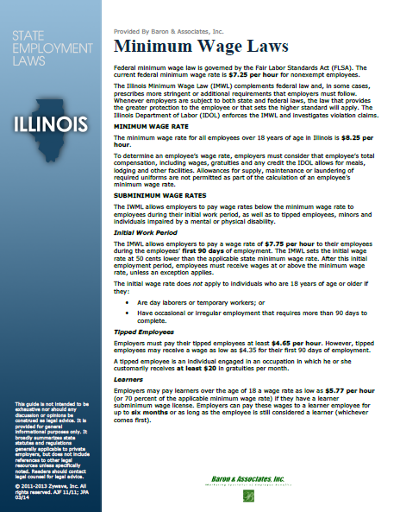
- Changes to HIPAA Rules: HITECH Act
- HSA Questions and Answers
- Section 125: Cafeteria Plan Common Questions

State-specific Legislation & Compliance
Keep track of regional legislative changes with valuable state-specific information related to COBRA, FMLA, disability insurance laws, state mandates, cellphone use while driving, domestic partner laws and rest/meal periods.
- Same-sex Marriage/Domestic Partner – Laws by State
- Cellphone Use/Texting While Driving – Laws by State
- State Disability Insurance Laws
- Health Insurance Mandates in the States
- Minimum Length of Meal Period – Laws by State

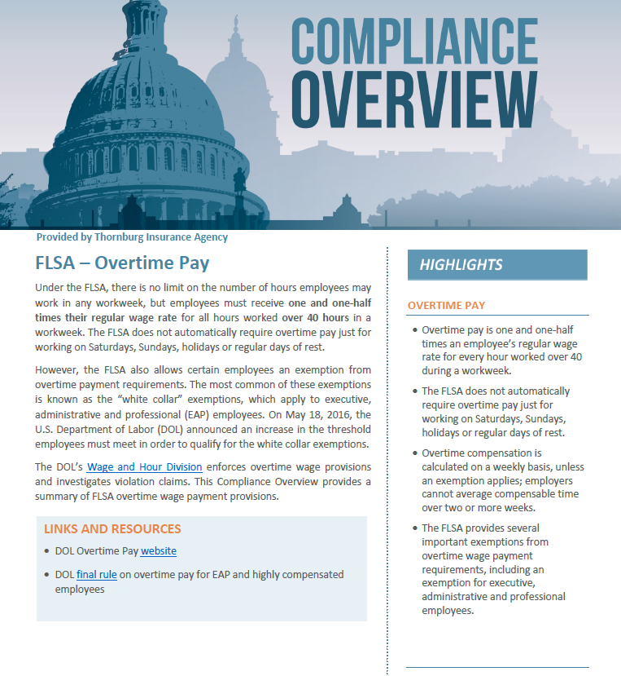

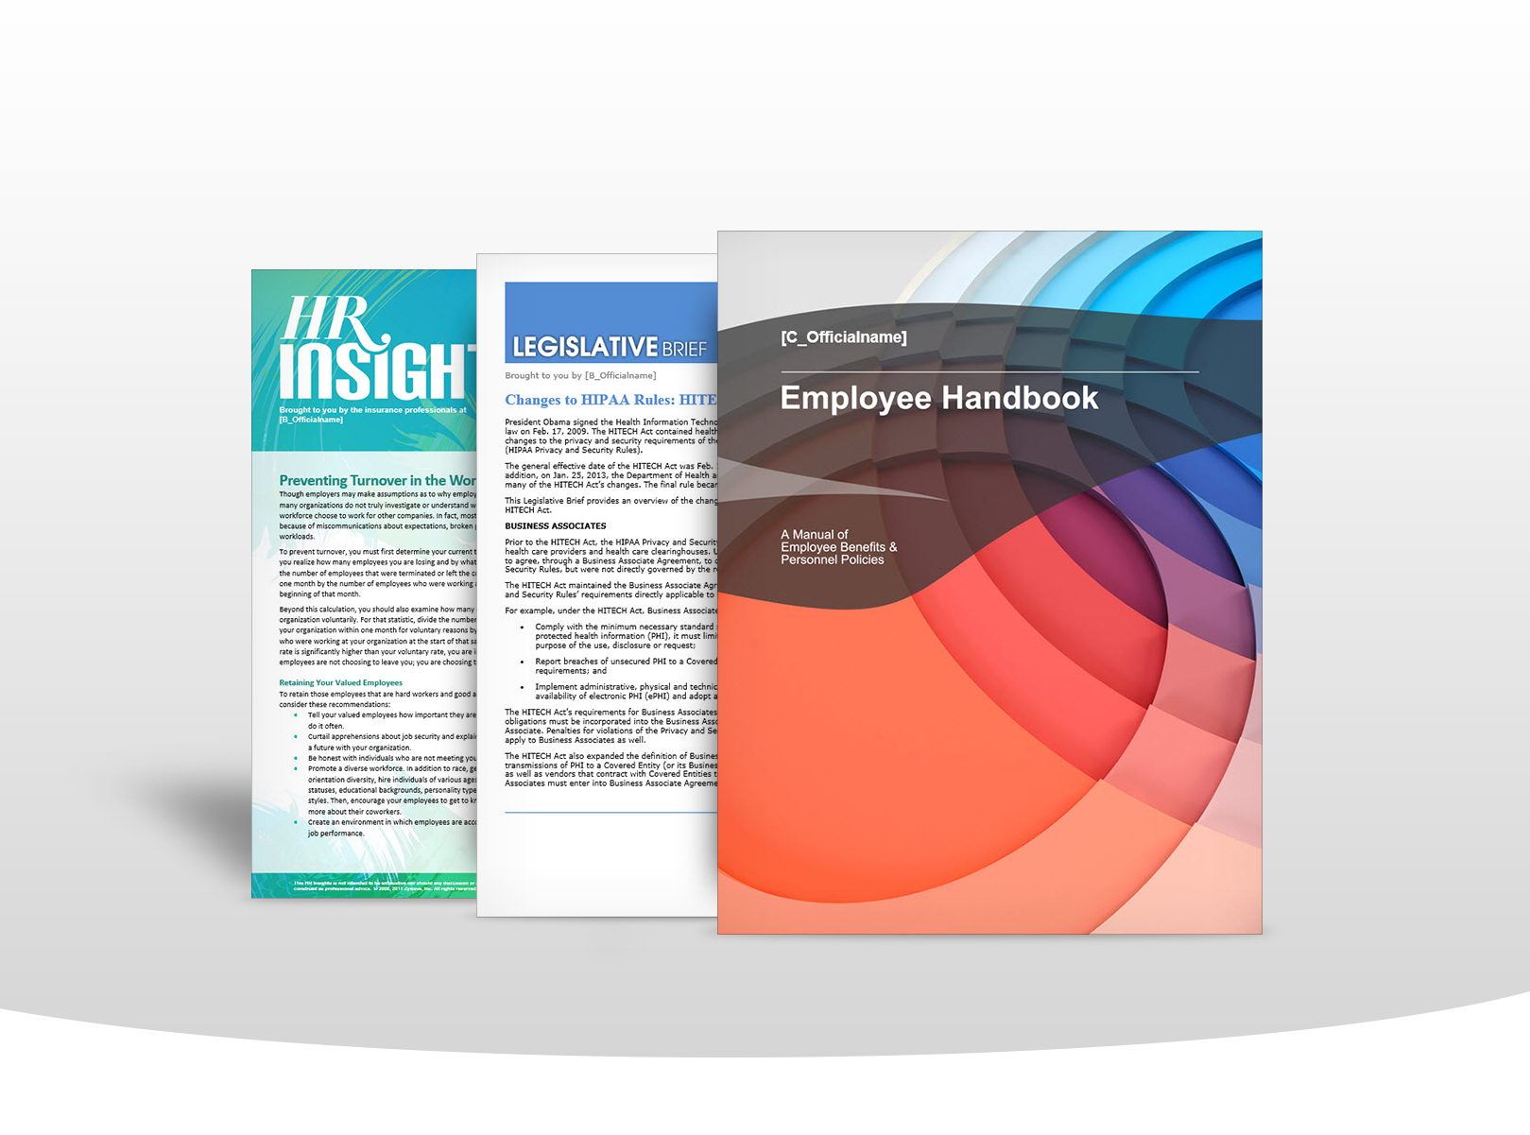
Human Resources

If your organization is like many others, your HR department is overworked and understaffed. We have the tools to help you stay up to date on HR trends, employment practices and social media strategies.

  - How do you keep up with HR trends, news and benefits administration information?
  - Are you compliant with current HR laws?
  - Is your employee handbook up to date?

Enrollment Tools
Health Plan Partners can deliver the resources you need to effectively communicate with your employees about benefits enrollment.
- Employee Benefits Meeting Presentation, Open
- Open Enrollment Education Opportunities
- 2016 Open Enrollment Checklist

HR Tools
Health Plan Partners has the resources you need to make sure that your HR department is running at peak efficiency.
- The Employee Handbook with Linked Table of Contents and Appendix
- We have a library of HR Forms that are professionally designed and electronically fillable
- The HR Toolkit – Interviewing
- The HR Toolkit – Onboarding

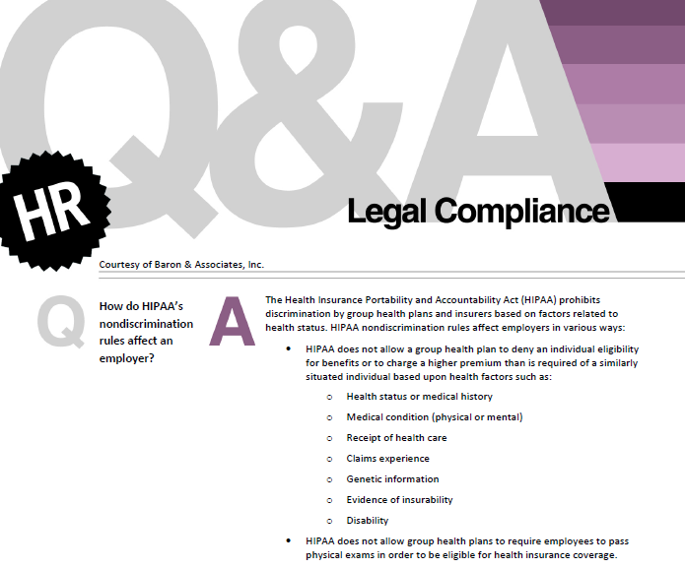
Educational Materials
We provide HR professionals with the resources they need to succeed.
- The topic-specific HR Insights series.
- The HR Q&A series

Succeed With Social Media
The Succeed with Social Media series offers your HR department the ability to improve corporate and benefits communications, connect with employees in a new and powerful way and recruit new talent.
- Succeed with Social Media – an Essential Guide for Employers
- The Sample Social Media Posts for Benefits Communications, Health and Wellness and Recruiting
- Social Media – Facebook

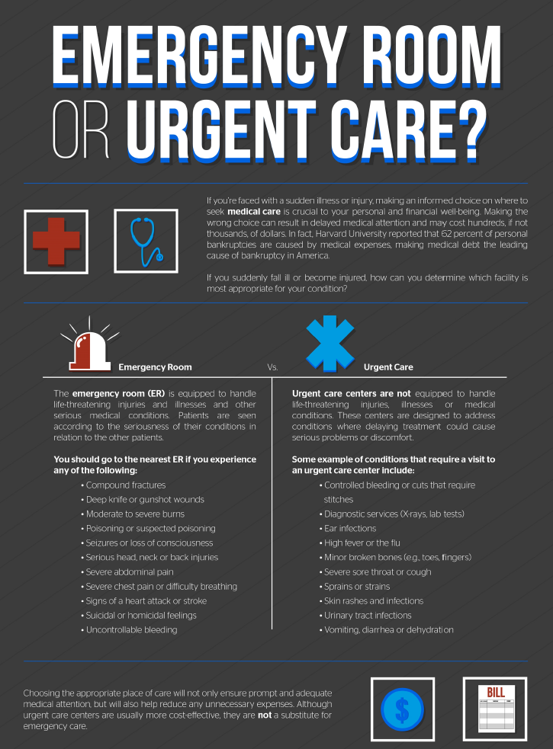

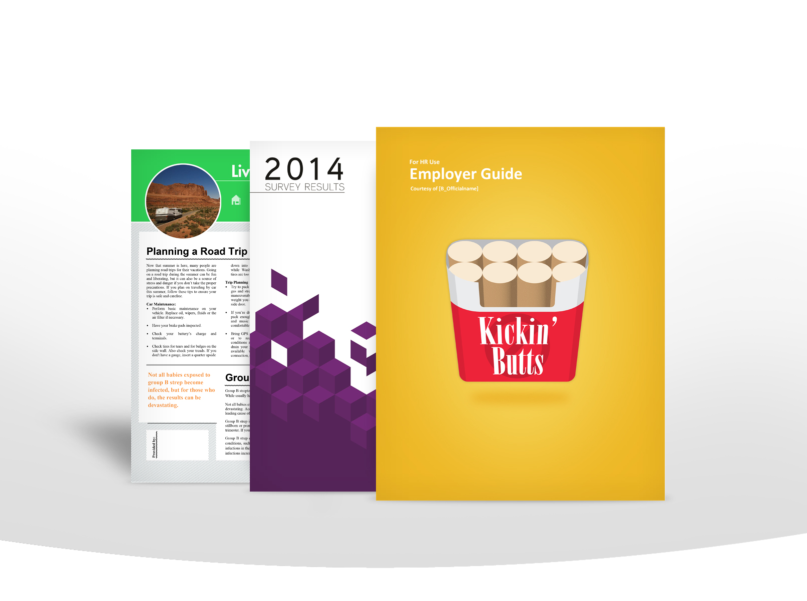
Workplace Wellness

Your workplace wellness program should certainly affect your employees on the job, but it should also impact their lives away from work.

  - Is your workplace wellness program saving your organization money?

  - Do you provide monthly newsletters and flyers to promote employee health and wellness?
  - We can provide you with several completely customizable wellness programs that deliver everything you need.

Wellness Resources
By promoting a healthy lifestyle, you can not only improve your employees’ quality of life, but also protect your workers and your business from unnecessary expenses. We have hundreds of health and wellness documents on a wide range of topics, including:
- Workplace wellness program how-to articles
- Low-cost wellness ideas
- Needs and interests surveys, assessments and evaluations
- Financial conservation
- Fitness
- General health
- Nutrition/obesity
- Smoking cessation
- Weight-loss Winner wellness competition

Employee Health & Wellness
We have over 600 employee communications designed to promote health and wellness both in the workplace and in your employees’ everyday lives.
- The Live Well, Work Well flyer Fitness First: Exercise Programs
- Prevention Newsletter: Everyday Health and Wellness
- The National Health Observances Calendar

Employee Consumerism Education
Teach your employees to be wise consumers of health care with dozens of educational articles and presentations that discuss topics ranging from health savings accounts to health care terminology.
- 10 Reasons to Love a Health Savings Account
- The Know Where to Go – Choosing the Right Health Care Provider Video
- This Generic Medications: They Keep You and Your Wallet Healthy

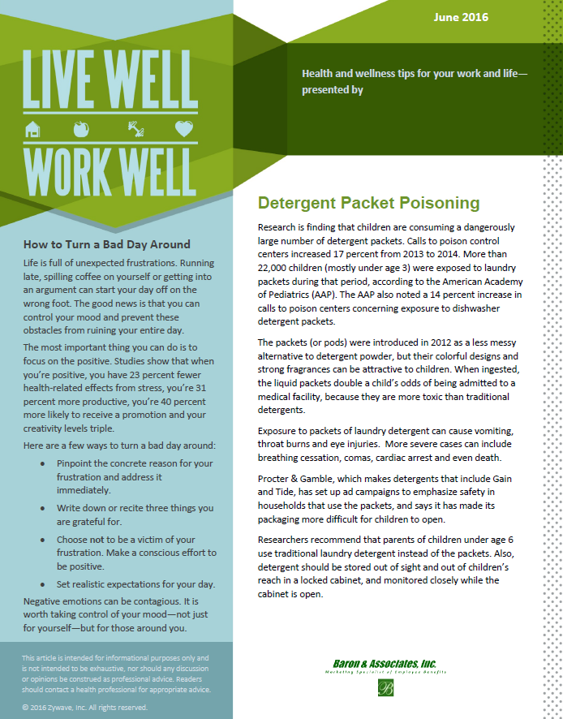

Benefits Communication
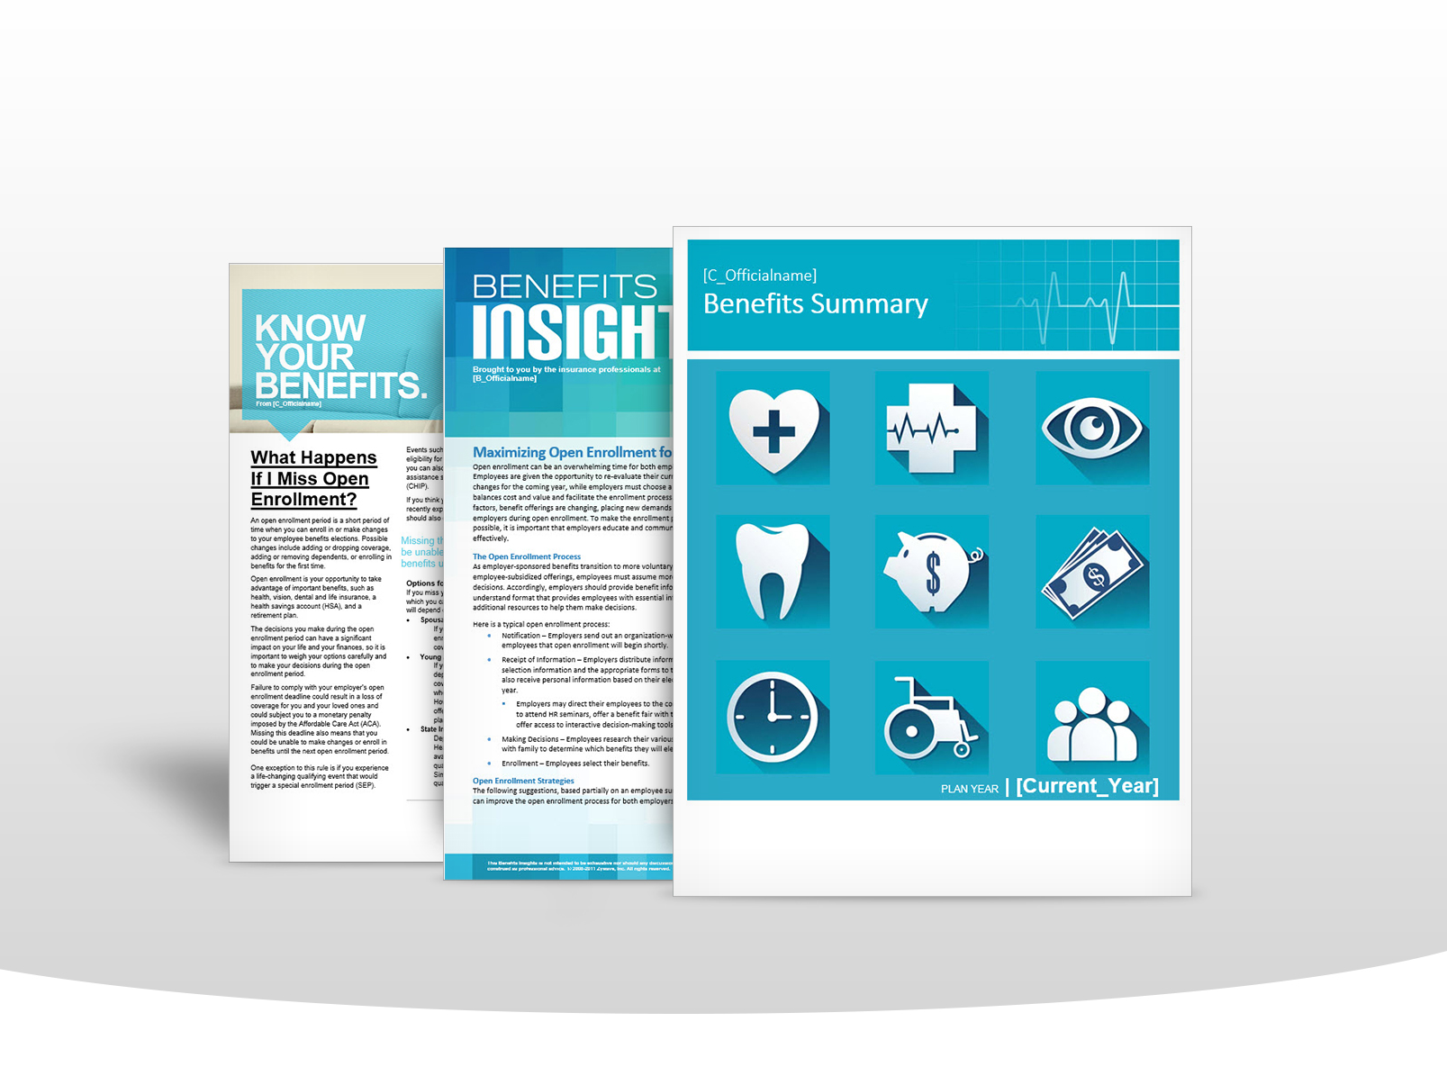
Get the most out of your benefits program by staying informed and keeping your employees educated. We provide customized benefits communications for both you and your employees on a variety of topics including benefits education, consumer driven health plans and retirement savings.

  - Could your enrollment services be more effective?

  - An attractive benefits package won’t retain employees without active enrollment.
  - Are you employees educated about all of their enrollment options?

Benefits Insights
The Benefits Insights series serves as a reliable resource for all types of benefits-related topics and issues and provides you with answers when you have questions.
- Employee Benefit Trends
- Domestic Partner Benefits
- Employee Benefit Plan Audits: Common Mistakes
- Educate Employees on the Importance of Life Insurance
- What Happens if an Employee Misses Open Enrollment?
- Comparing MSAs, HSAs, HRAs and FSAs—Which Approach is Best?

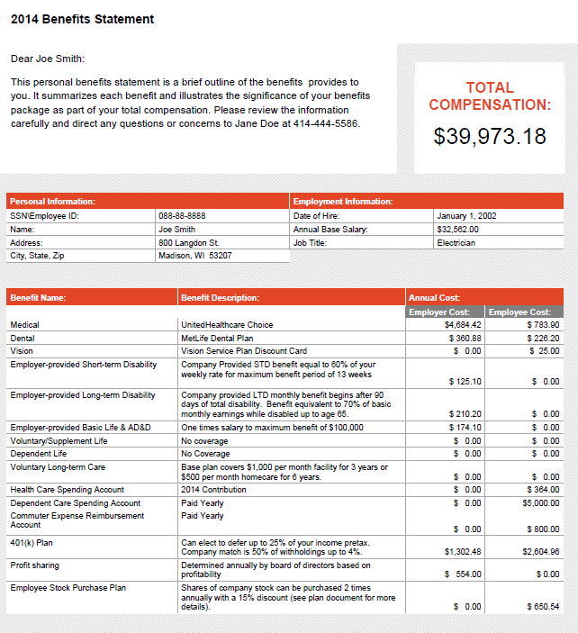
Employer Newsletters
Our employer newsletters provide an overview of recent events and benefits trends to keep you in the loop.
- Benefits Buzz
- Benefits Bulletin

Total Compensation Statements
Your employee benefits package is only as valuable as your employees believe it to be. Our total compensation statements show your employees the true value of the benefits you provide by listing the exact dollar amount you pay for their benefits packages and displaying it as a percentage of their income.
- The Total Compensation Statement Packet
- The Employee Benefits Statement

Employee Newsletters
Save your HR department’s valuable time and resources while increasing productivity. The Live Well, Work Well Newsletter is a customizable monthly newsletter that provides your employees with wellness, fitness, nutrition and financial tips, and it includes a healthy recipe in every issue.

Benefits Announcements and Educational Material
Your benefits program is most effective when your employees are fully informed and actively participating. We provide announcements and summaries to inform them of plan updates or changes, and the educational materials they need to put your benefits plan to good use.
- The Benefits 101 Guide
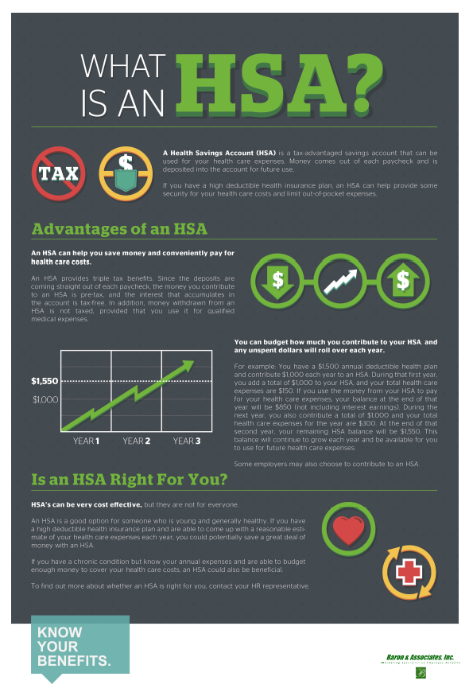
- The Voluntary Benefits - Employee Guide
- The Benefits Summary
- The Health Reimbursement Arrangement (HRA) Eligible Expenses
- The Understanding a Health Savings Account (HSA)
- The Be a Wise Health Care Consumer—25 Ways to Reduce Your Health Care Costs
- The 10 Easy Ways to Stretch Your Health Care Dollars
- The Health Savings Accounts
- The Savings Fitness: How Much Money Do I Need to Retire?

Retirement Communications
We can provide you with a variety of employee communications and resources to assist plan sponsors with fiduciary responsibility.
- The Top 10 Ways to Prepare for Retirement
- The 401(k) Plan Potential Mistakes
- Glossary of Retirement Terms

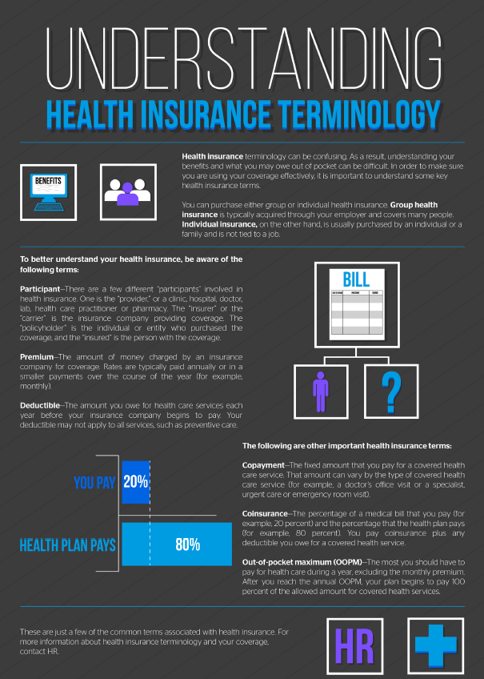
Service | Description | Check here if your current broker offers this service
Insurance Market Access | We provide access to essentially all insurance and administration markets.
National Affiliations | In addition to our own talented professionals and specialized value-added services, we have a wealth of resources available to us through several national affiliations.
Strategic Planning | We develop a customized, comprehensive strategic plan for each of our clients that determines objectives and positions benefit strategies to work in support of the overall corporate direction. We provide detailed outlines of the actions needed to accomplish those goals. Once implemented, we review and refine the benefit plan regularly.
Five-star Service | We pride ourselves on the level of knowledge and service we bring to our clients. All of our clients are assigned a team of professionals dedicated to serving their needs. Each client can access our team through a single point of contact, making working with us seamless and easy.
Experience | We have proven dedication and a commitment to excellence in our service to the business community, as well as the institutional knowledge and resourcefulness to navigate any circumstances.
Technology | We use state-of-the-art technology to provide our customers with the latest data procurement and analysis techniques, as well as legislative resources and tools for communication and human resources administration.
Actuarial Services | When needed, we employ the services of professional actuaries to assist with calculations critical to your employee benefits plans.
Health Care Reform | Our agency offers hundreds of up-to-date, easy-to-understand documents explaining all aspects of health care reform to help both employers and employees understand the law and its implications.
Full-time Employee Tracking | We provide the tools you need to determine which variable-hour employees are considered full-time employees under the Affordable Care Act (ACA) and to know when they must be offered health coverage.
Legislative Briefs | We offer an exclusive Legislative Brief publication, which summarizes recent federal legislative developments involving insurance and employee benefits, to help you understand laws, including the ACA, COBRA, HIPAA, FMLA, ADA, GINA, Medicare Part D and more.
Client Portal | All of our clients receive access to a personalized website offering both customized and recommended resources to help fulfill unique administration, legislative compliance and communication needs.
Data Analysis | Using employee claims data from our client’s carriers or TPA, the Internet-based Decision Master® Warehouse system analyzes your data and helps you discover how and where to adjust your plan design to save money. We can even model recommended changes to show you the potential savings.
Custom Communication | We can assist you with all phases of employee communication, from employee meetings to payroll stuffers to informative brochures about employee benefits and wellness.
Human Resources Tools and Support | HRconnection®, a powerful employee communication portal, is available to you. This online tool helps you increase productivity, streamline processes, improve communication and save money.
Pharmacy Benefits Services | Through arrangements with two leading pharmacy benefits managers, we have access to national pharmacy networks, significant discounts, pharmacy benefits, modeling tools and more.
Voluntary Benefits | With the Voluntary Benefits Guide and related materials, we can help you understand, plan, implement and educate employees about this growing and important area of employee benefits.
HR Hotline | The HR Hotline gives you access to on-demand HR expertise and advice. HR professionals, available by phone or email, are ready to answer your HR-related questions.
Community | While partnering with us, you gain access to professionals from all over the country through the Community section of your client portal. An answer to a problem you have is just an email away.
Benefit Plan Analysis | We see a simplified way for you to approach the benefits plan design process. With PlanAdvisor®, we help you analyze your benefits plan costs against reliable benchmark information, project the impact of medical and dental plan design changes, estimate your renewal costs and streamline the plan selection process for your employees.
Wellness Programs | We provide you with months-long wellness programs to boost employee fitness and keep insurance costs down, complete with privacy and reward guidance.
Industry News | We provide detailed monthly and quarterly summaries of changes in federal benefits regulations.

