.

+
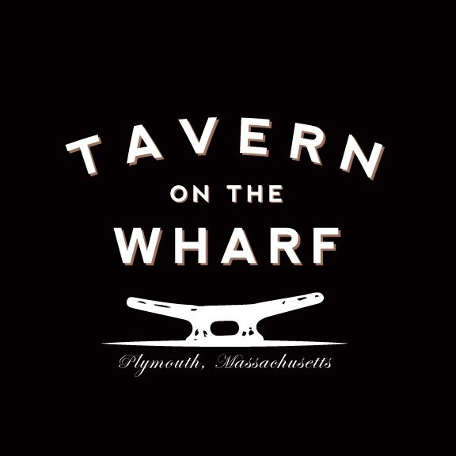

Thank you for choosing Tavern on the Wharf for your upcoming event! As a locally owned and operated restaurant, we take the utmost pride in our guest satisfaction. From the freshest seafood to our certified angus beef, here at Tavern on the Wharf we expect nothing but the best for our guests.

We offer several options and accommodations for your gathering. Our Fish Bowl can seat 30. Back Bar seats 70 and patio seats 120. Cocktail parties and standing room events can hold up to 20 more. We try to accommodate all our guests’ special requests, please feel free to ask if we can help you in any way possible.

7% tax fee 18% staff fee 5% admin fee

Brunch Buffet
20 per person
Assorted Breakfast Pastries
Fruit Platter
Scrambled Eggs
Apple Smoked Bacon
Maple Sausage
Crispy Home Fries
French Toast or Buttermilk Pancakes
Add
Chicken Marsala 4
Baked Local Cod 6
Stuffed Shrimp 8
Apple Cranberry Stuffed Chicken 4

Carving Stations
150 Chef’s Fee
Slow Roasted Prime Rib (minimum 30 people) 15
With horseradish sauce, red wine demi glaze and dinner rolls
Herb Crusted Turkey Breast (minimum 25 people) 9
With cranberry compote, turkey sauce and dinner rolls
Roasted Brown Sugar Glazed Ham (minimum 30 people) 9
With honey Dijon glaze and dinner rolls
Pork Loin (minimum 20 people) 9
With caramel apple sauce, grain mustard pork sauce and dinner rolls

Omelet Station 8
Farm fresh vegetables, ham, bacon, linguica and assorted cheeses

Waffle Bar 6
Freshly made buttermilk waffles served with fresh strawberries, blueberries, raspberries, blackberries, Chantilly cream and pure maple syrup

Continental Breakfast
14 per person
Assorted Breakfast pastries
Baked brie with fruit jams
Tropical fruit platter
Smoked salmon with condiments and bagel chips
Coffee tea and juice station
Add
Scrambled eggs 4
Bacon 3
Sausage 3

Hot Hors D’oeuvres per piece
Seafood Stuffed Mushrooms 3
Petite Meatball Pomodoro 3
Cheese Arancini ala Vodka 3
Panko Chicken Tenders 3
Thai Chicken Satay 3
Teriyaki Beef Satay 3
Chicken Wings 3
Buffalo Chicken Dip Cups 3
Coconut Crusted Shrimp 3
Mini Lump Crab Cakes 3
Scallop wrapped in Bacon 4
Clams Casinos 4
Mini Stuffed Quahogs 4
Beef Wellington 4
Petite Lobster Mac & Cheese Cups 4
Fish & Chips Cones 4
Lobster Bisque Soup Shouter with Sherry Cream 4
Vegetable Spring Rolls – vegetarian 3

Cold Hors D’oeuvres per piece
Prosciutto and Melon 3
Smoked Salmon on Toast 4
Sliced Tenderloin Crostinos 4
Shrimp Cocktail 4
Petite Lobster Rolls 5
Summer Heirloom Gazpacho Shooter 3
Smoked Salmon Crostinos 4
Tomato Mozzarella Skewers – vegetarian 3
Tomato & Fresh Mozzarella Bruschetta vegan 3
Ahi Tuna Snapps 4
Asian Vegetable Cucumber Cup – Vegan 3
Herb Goat Cheese Crostinos 3

Raw Bar per piece
(150 charge for Shucker)
Shrimp Cocktail 4
Blue Point Oysters 3
Chatham Little Neck Clams 3
Lobster Claws 5
King Crab Legs 7
Scallops in half Shell 6

Stationary Displays
Fresh Fruit Display 4
(Minimum 25 People)
Cheese Board 4
Assorted imported and local cheese with mixed berries, grapes and crackers
(Minimum 25 People)
Vegetable Crudités 3
Raw Seasonal Vegetables with 2 dipping sauces
(Minimum 25 People)
Smoked Salmon 6
Scottish Smoked Salmon with diced hard-boiled eggs, Bermuda onion, capers, dill crème franches, and caviar with parmesan crostino’s
(Minimum 25 People)

Sandwich Platters
Assorted Meat Wraps 6
Assorted Vegetarian Wraps 5
Tuna Salad Finger Rolls 4
Chicken Salad Finger Rolls 4
Harvest Chicken Salad Wraps 6
Mini Croissant Lobster Salad Rolls 8
Tea Sandwiches assorted 3
All platters come with choice of pasta, potato, mixed green house salad

Tavern Buffet
38 per person
(Minimum 25 People)

Salad
(please choose one)
Tavern Salad
Potato Salad
Caprese Salad Platter

Entrées
(please choose two)
Slow Roasted Sliced Prime Rib
Chicken Saltimbocca
Stuffed Local Sole (mixed seafood stuffing)
Seafood Casserole (mixed seafood with lobster bisque)
Grilled Pork Tender Loin with Pineapple Relish

Sides
(please choose two)
Roasted potato
Potato Gratin
Mashed Yukon Gold Potato
Saffron Rice
Broccoli and Cauliflower Gratin
Buttered Corn on the Cob
Zucchini Parmesan
Sautéed Vegetable Medley

Dessert
Please choose one
Apple Crisp
Key Lime Pie
Tiramisu Tart
New York Cheesecake
Cookies & Brownies Platter

Plymouth Harbor
42 per person
Platted or Buffet style

First Course
(please choose one)
Homemade New England Clam Chowder
Chicken Wild Rice Soup
Seafood Stew
House Salad
Traditional Caesar Salad
Caprese Salad
Second Course
(please choose two)
Pan Roasted Boneless Half Chicken
Herb Crusted Atlantic salmon
Grilled Pork Tenderloin with Apple Cranberry Chutney
Chicken Marsala
Sautéed Chicken Breast with portabella mushrooms, cherry tomatoes in a marsala wine sauce
Sides
(please choose two)
Asparagus with Mornay Sauce
Roasted Potatoes with garlic herb butter
Red Bliss Mashed Potato
Saffron Rice
Glazed Baby Carrots
Broccoli with garlic butter

Plymouth Light
47 per person
First Course
(please choose one)

Homemade New England Clam Chowder
Lobster Corn Bisque
Roasted Beet Salad with candied pecans, caramelized shallots and goat cheese
Chopped Vegetable Salad
Seasonal vegetables tossed with balsamic vinaigrette served with radicchio and endive
Grilled Artichoke Salad
artichoke hearts tossed with honey lime vinaigrette served with crème brule grapefruit

Second Course
(please choose two)
Atlantic Salmon en Croute
Atlantic Salmon wrapped in puff pastry with puree artichokes
Chicken Mediterranean
Kalamata olives, sundried tomato, sautéed artichokes and capers in a lemon broth
Braised Bourbon Beef Tips
Sautéed with mushroom, pearl onions and bourbon beef sauce
Cod Oscar
baked with asparagus, crab and hollandaise sauce

Sides
(please choose two)
Sweet Potato Mash
Grilled Polenta
Potato Dauphinoise
Sautee Broccolini
Haricot Verts with Pecan Butter
Roasted Rainbow beets

Town Wharf
55 per person
First Course
(please choose one)
Heirloom Tomato Salad
Heirloom Tomatoes with micro basil mozzarella pearls
Shaved Shallots and balsamic syrup vinaigrette
Smoked Salmon Caviar Plate
Scottish smoked salmon with hard boil eggs, capers, onions and caviar with rye crostinos and dill crème fraiche
Lobster Stew
Sweet lobster meat with celery, onions, corn and potatoes in a sherry flavored cream sauce
Lola Rosa Bouquet Salad
Baby lola Rosa greens with micro herbs in a tomato vase served with raspberry coulis dressings

Second Course
(please choose two)
Beef Wellington
Filet mignon with Dijon mustard, mushroom duxelles
Potato Crusted Cod Loin
Sweet potato crusted local cod loin with lime butter broth
Boneless Half Chicken
Pan roasted boneless half chicken with thyme au jus
Seared Scallops
Pan seared jumbo sea scallops with champagne beurre blanc and tomato concassée

Sides
(please choose two)
Broccolini
White Asparagus
Maple Baby Carrots
Jasmine Rice
Sweet Pea Risotto
Twice Baked Potato

All packages come with complimentary cookies and brownies
Or
Chef’s dessert of the day

We can also customize a menu or package that will make your event day special.
Pricing based on menu selections.

