

**Community Counseling Center of Mercer County**

2201 East State Street Hermitage, PA 16148

Toll Free: 1-866-853-7758

Phone: 724-981-7141 Fax: 724-981-7148 TTY: 724-981-4327

[www.cccmer.org](http://www.cccmer.org)

• Family Based • Behavioral Health Rehabilitation Services • School Based • Respite Care • Outpatient Mental Health and Drug & Alcohol

• Psychiatric Rehabilitation • Residential & Housing • West Central Center for the Deaf • Vocational & Employment Services



# Community Counseling Center

# Psychology Internship

**2016-2017**

[****](https://online.unitedway.org/site///online.unitedway.org/site/)

Proud Member of United Way of Mercer County and the Grove City Area United Way

Greenville Office 724-588-6490 Grove City Office 724-458-4144 ECHO Center 724-981-1166

Table of Contents

1. Introduction……………………………...3
2. Program………………………………....4
3. Applicants and Application Process….4
4. Goals and Objectives……………….....4
5. Training Model………………………….5
6. Accreditation Status……………….......6
7. Internship Site……………………….....6
8. Clerical and Technical Support……….6
9. Equipment and Training Materials……7
10. Clinical Experiences…………………...7
11. Didactic Training……………………… ..9
12. Supervision……………………………..9
13. Evaluation Procedures……………….. 10
14. Clinical Faculty……………………….. ..11
15. Application Procedure…………………11
16. Additional Information……………….. ..12
17. About the Area………………………….12
18. Appendix A: Due Process……………..14
19. Appendix B: Intern Grievance…………16

Dear Internship Applicant,

Thank you for your interest in our psychology internship training program. The Community Counseling Center (CCC) is a rural community mental health agency that offers a wide range of programs and services to adults, adolescents, children, and families in the Mercer County, PA area. Our agency is committed to providing accessible and clinically effective services in an at-need region, and we are committed to training potential psychologists within a generalist practice framework. Our doctoral level internship maintains membership in the Association of Psychology Postdoctoral and Internship Centers (APPIC)

Interns at Community Counseling Center are offered a broad range of training opportunities, which include assessment and diagnosis, psychotherapeutic intervention, supervision, and consultation. Trainees are provided with the opportunities to provide the following services: psychological testing and report writing, intake diagnostic assessments, individual, group, and family/couple psychotherapy, and school-based therapy. The overall program goal is to prepare interns for professional practice in an outpatient mental health setting.

Our staff at CCC is committed to the highest quality of internship training. We strive to provide our interns with rich experiences that combine didactic training, scholarly research, and experiential activities. Such activities include individual supervision, group supervision, didactic seminars, and clinical treatment teams.

We hope that you will consider our internship program. We look forward to receiving your application.

Sincerely,

Lisa Phillips, Ph.D

Training Director

724-981-7141

[lphillips@cccmer.org](mailto:lphillips@cccmer.org)

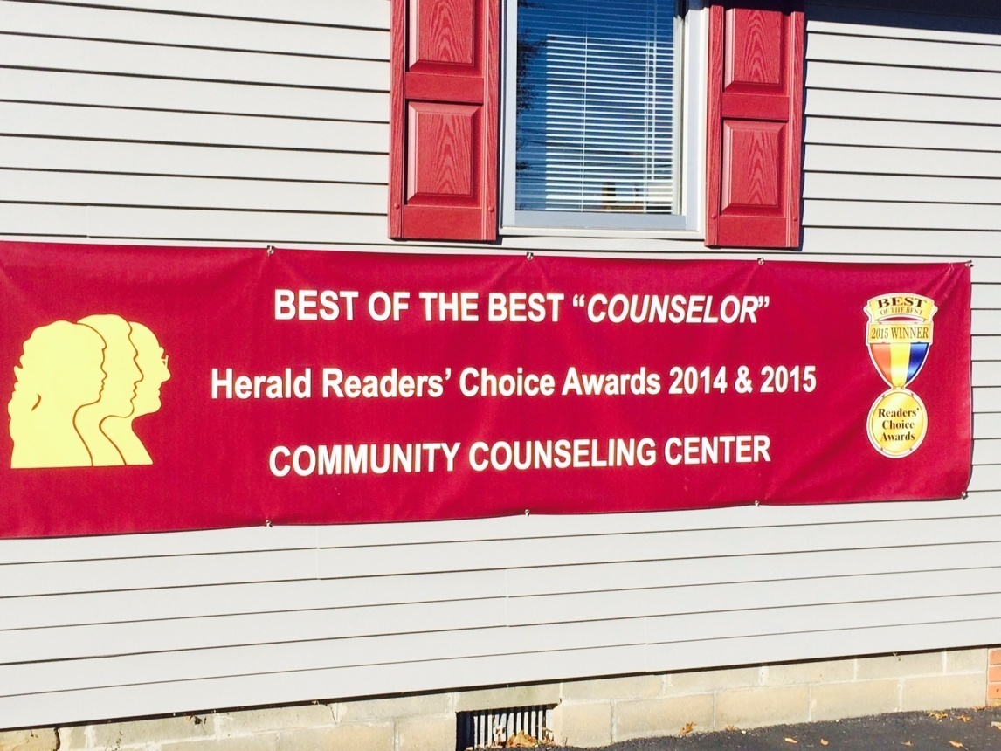

**PSYCHOLOGY INTERNSHIP PROGRAM**

The Community Counseling Center (CCC) of Mercer County Pennsylvania began offering post-practicum, doctoral level internships in 2004. CCC is well established within the community and is committed to providing high quality training to doctoral interns desiring experience with a community mental health population in a semi-rural setting. The training philosophy is one based on the Scholar-Practitioner model. Our doctoral internship promotes the acquisition of skills necessary to provide competent psychological assessment, consultation, supervision, and intervention. Through a combination of supervised clinical experience and didactic training, our interns are prepared to function as an entry-level professional psychology resident in a health care, community mental health, or private practice setting.

**GOALS AND OBJECTIVES**

The primary goal of the internship program at Community Counseling Center is to prepare psychology graduate students for the professional and ethical practice of general psychology in semi-rural communities. In order to reach this goal the intern is involved in a myriad of experiences. The applied setting of the internship enhances skill development through progressive, sequential, and cumulative tasks and training opportunities.

Program Training Goals

1. **Goal:** To advance clinical knowledge and skills in the areas of assessment, diagnosis, intervention, supervision, and consultation, so that each intern is able to…

**Objectives**:

* 1. Develop assessment and diagnostic skills through diagnostic clinical interviews and the provision of formal psychological testing batteries.

**Competencies:** Intern will demonstrate advanced diagnostic knowledge, and will be able to effectively administer both a thorough clinical interview and a multitude of psychological assessments.

* 1. Accurately score, interpret, and report on assessment findings.

**Competencies:** Intern will demonstrate accurate scoring and interpretation of test materials. Intern will be able to write coherent and grammatically proficient assessment reports.

* 1. Carry a diverse client caseload in outpatient, community, school, and residential settings, and to provide individual, family, couples and group psychotherapy, through the bridging of theoretical knowledge and clinical practice.

**Competencies:** Intern will demonstrate growth in their case conceptualization, use of scientific and theoretically-grounded thinking, and the use of theory as a foundation for sound clinical judgment.

* 1. Function ethically with regard to establishing therapeutic relationship, setting realistic treatment goals, and monitoring progress of clients.

**Competencies:** Intern will demonstrate proficiency in rapport building and will be able to use appropriate clinical judgment at the onset and termination of therapy, as well as when setting treatment goals.

* 1. Provide supervision and consultation, both internally and in an outreach capacity.

**Competencies:** Intern will demonstrate intermediate to advanced skill in assessing for supervisory/consultative needs and providing supervisory feedback, consultation or trainings, and in providing outreach to a multitude of programs.

1. **Goal:** Develop skills relating to the use of supervisory process and case presentations.

**Objective:** Intern will attend weekly individual and group supervisions and will actively participate in the supervisory process.

**Competencies:** Intern will demonstrate intermediate ability to use both process and content-oriented supervision, will be able to present meaningful case material weekly, and will pose relevant questions and accept feedback in a non-defensive manner.

1. **Goal:** Increase awareness and sensitivity related to multicultural differences and diversity, including the development of a greater understanding of community mental health and the unique challenges inherent in a rural setting.

**Objectives:**

* 1. To attend trainings on cultural diversity, seek opportunities to work with clients of various cultural, ethnic and socioeconomic backgrounds, and to consult with supervisors regarding cultural issues.

**Competency:** Intern will demonstrate an advanced level of respect and awareness of multicultural and individual diversity.

* 1. To assume a professional role in a clinical, multidisciplinary, complex rural setting, including personal and provider agency relationship development.

**Competencies:** Intern will demonstrate organizational and environmental awareness, collaborative multidisciplinary practice, and effective internal and external communication.

1. **Goal:** Develop a professional identity as an ethical psychologist with increasing confidence and trust in one’s own clinical skills and judgment.

**Objective:** To utilize individual and group supervision, training, and professional mentoring opportunities to increase personal and clinical competence.

**Competencies:** Intern will demonstrate intermediate to advanced professional conduct, ethical comportment, accurate self-assessment and judgment, and effective self- and time-management.

**TRAINING MODEL**

Community Counseling Center utilizes the Scholar-Practitioner Model of training. Our training is built on the premise that in order to provide competent psychological services one must remain cognizant of the current research available in the field. Therefore, psychological interventions are informed by research and through an awareness and sensitivity for diversity. Supervision, didactic trainings, and utilization of a variety of treatment modalities encourage the interns to continue their educational development through scholarly inquiry, and serve to prepare them to function as an entry-level professional psychologist in a number of health care settings. Moreover, a developmental approach is taken with regard to intern performance, as the trainees are expected to become increasingly autonomous in their clinical work as the year progresses. Close clinical supervision of the intern’s intensive experiential training includes two licensed psychologist supervisors maintain weekly contact, either via telephone, or in person, in order to discuss matters related to the interns, or the internship program. In addition, quarterly clinical meetings for all faculty and staff involved in the doctoral training program are held. The training model if emphasized by three key areas: clinical contact, training diversity, and opportunities for specialized practice.

1. *Clinical Contact:* The Internship Program at Community Counseling Center focuses primarily upon training generalists, and provides trainees with opportunties for expsure to a wide range of client populations and clinical disordersThe internship year is seen as the culmination of doctoral training in psychology and as the appropriate time to make the transition between academia and the day-to-day world of clinical service. Community Counseling Center offers such an opportunity to blend theory and realistic practice, as interns spend up to half of their time on internship year doing clinical work.
2. *Training Diversity:* The internship program at CCC is highly committed to both training in diversity/multicultural issues, as well as in the recruitment of interns from various cultural and/or minority groups. To help interns build multicultural awareness and sensitivity, they are provided with many opportunities to work with clients of various ages, genders, gender identities, ethnicities/race, socioeconomic statuses, and abilities. Moreover, interns are trained in didactic seminars, treatment team meetings, and through formal trainings on various aspects of diversity. Interns may also become members of a Diversity Training Committee, in which they are provided with opportunities to train and educate both internal clinical staff and external programs on issues related to diversity. The internship program is also committed to improving recruitment and retention of interns and staff from diverse backgrounds.
3. *Opportunities for Specialized Practice:* In addition to generalist training, the internship program provides opportunities for exposure to and/or training in more specialized areas. Areas in which interns have the opportunity to train include, but are not limited to, psychological testing and assessment, Trauma Informed Care/Trauma-Focused Cognitive Behavioral Therapy (TF-CBT), Parent-Child Interaction Therapy (PCIT), Eye Movement Desensitization and Reprocessing (EMDR), Substance Use, Group Therapy, Couples and Family Therapy, Motivational Interviewing (MI), and Clinical Hypnosis. It should be noted that for some specialized areas of training, such as PCIT, interns are required to commit to completing their post-doctoral training at CCC, as the training and implementation of such skills are expected to take more than one year.

**ACCREDITATION STATUS**

Community Counseling Center maintains membership in The Association of Psychology Postdoctoral and Internship Centers (APPIC). Community Counseling Center is not accredited by the American Psychological Association (APA); however, in 2013, Community Counseling Center was the proud recipient of an APA grant to commence the self-study for the addition of another internship position along with APA accreditation status.

**INTERNSHIP SITE**

**Community Counseling Center**

The Community Counseling Center of Mercer County is located at 2201 East State Street, Hermitage, PA 16148, and has various satellite locations throughout Mercer County. There are spacious, free of cost, parking lots at each site. CCC has provided comprehensive community behavioral health services to since 1957. The Center is a private, non-profit corporation and a member of the United Way.

Community Counseling Center offers a comprehensive continuum of children and adult clinical services. Outpatient services include the following: brief and long-term counseling, couple, family and group therapies, community-based treatment including family-based psychotherapy, school-based services, deaf and hard-of-hearing services, drug and alcohol treatment for adolescents and adults, evaluation and testing, children and adult psychiatric services, day treatment programs, and vocational services. Other services include residential treatment programs, supported housing, psychiatric rehabilitation, consultation, training, and education.

*Hermitage:*

Interns spend approximately three to four days per week at the Hermitage site, which is the largest CCC office. Services provided at the Hermitage office include psychotherapy, psychiatric medication management, psychiatric rehabilitation, and other community and residential programs (e.g., job coaching). Moreover, this office houses several group and conference rooms, and staff treatment team meetings, clinical meetings, and group supervision meetings are provided here. Interns have private offices, which are located in close proximity to each other and to supervisors, and each office is equipped with a desk, bookshelf, computer, chairs, and a telephone with access to the agency voicemail system. At the very least, interns will be on-site in Hermitage on Wednesdays and Fridays to attend meetings, trainings, and supervision. The Hermitage site is also home to the psychological testing resource room, and interns will have keys to access this room to obtain testing materials for OVR and psychological testing batteries.

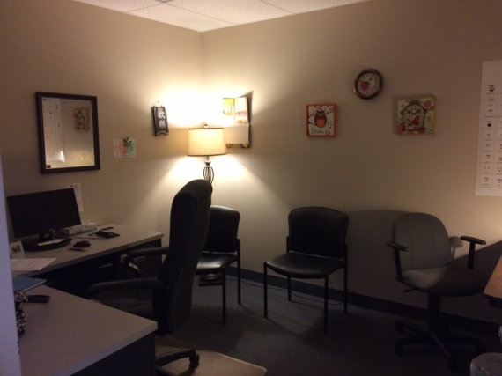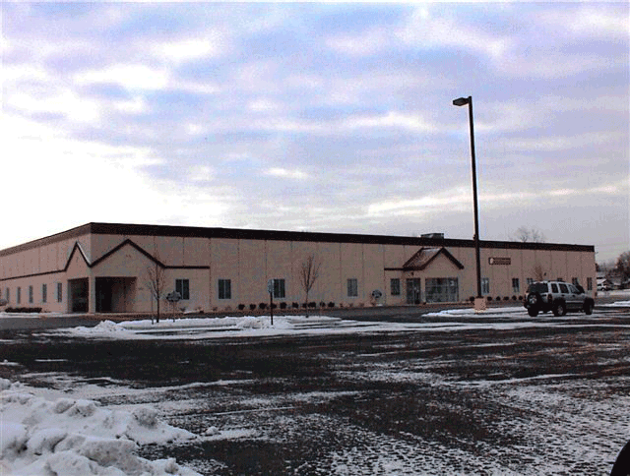

Hermitage Site

*Greenville:*

Interns spend approximately one day per week at the Greenville office, which is located at 77 N. Main Street in Greenville, PA 16125. Services provided at this site include psychotherapy, psychiatric medication management, peer support, and job coaching. This office houses several offices and two larger conference rooms. A typical day for interns at the Greenville site includes providing individual psychotherapy, consultation with other treatment providers at the site, and one hour of individual supervision. Trainees are provided with an office and computer, which is shared by other clinicians.

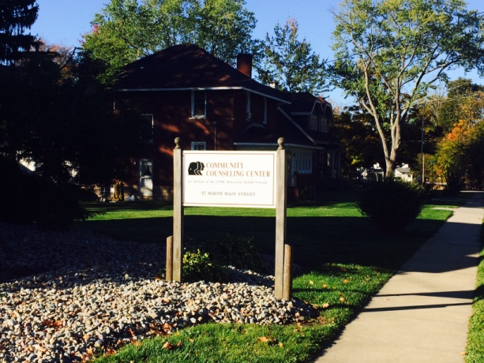 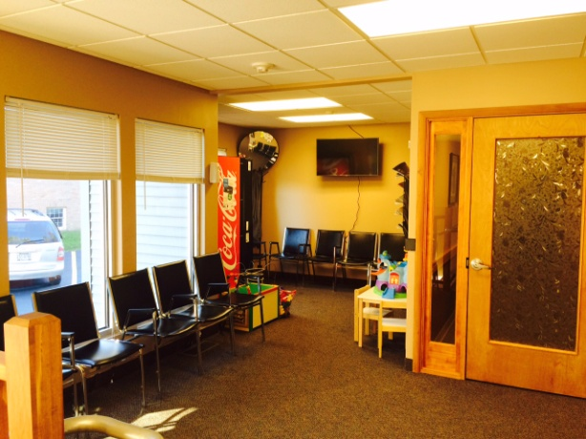

Greenville Site

*Grove City:*

The Grove City office is located at 107 Breckenridge Street, Suite 1, in Grove City, PA 16127. At present, one full time clinician provides therapy services at this site. Interns may be required to spend one-half to one full day at this site per week, to provide psychotherapy.

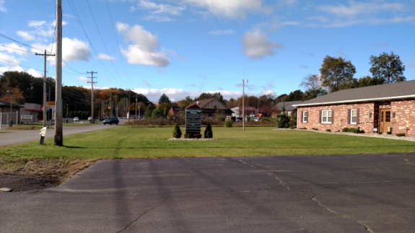

Grove City Site

**Clerical and Technical Support**

The Community Counseling Center of Mercer County is a full functioning business with office managers and clerical staff that help assist the interns in reception duties, scheduling appointments, and scanning files. Secretarial support services are available to our interns throughout the day and evening. There is often six full time clerical staff to assist interns with administrative tasks on a daily basis. The Human Resources department also assists our interns in attending orientation and new employee trainings, and with establishing medical and dental insurance, and ensuring that the required paperwork is efficiently completed prior to the intern start date. A full information technology department, staffed by two full time employees, is available to interns for any technical problems or support needed throughout the day. Secretarial staff, Human Resources staff, and IT staff are always available to our interns though email or by phone.

**Equipment and Training Materials**

Our interns have full access to drives on our computer system which contain a multitude of resources, including an APPIC training and resource folder to utilize training materials with clients and to use towards professional development. All interns are provided with an agency email address, their own private office, a laptop computer and an iPad Mini for use in the schools, and access to the electronic health record software, the internet, and Microsoft software, as well as local printers or copiers that print and scan documents. Copy machines, printers, scanners, fax machines, and any required office supplies are readily available for intern use, including requests for preferred items (e.g., gel pens, steno-pads, sharpie markers). Interns are also provided with decorations and personalized materials for their offices, including a nameplate for their door, lamps, whiteboards, corkboards, mirrors, artwork, and calendars. They are also welcome to bring in items to personalize their office. Finally, therapeutic materials (art supplies, therapeutic games, dolls, puppets, and building blocks) are available at the agency for use by interns working with children. Additionally, interns are provided with audio recorders, or are welcome to bring their own, to use for tape reviews in individual and group supervision.

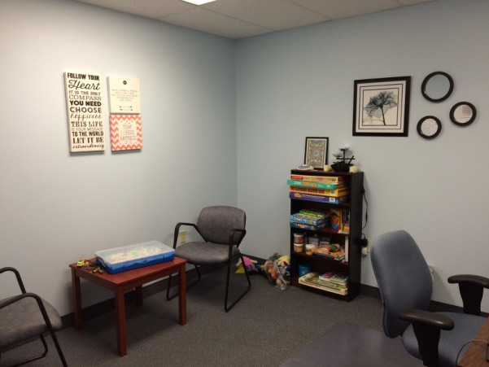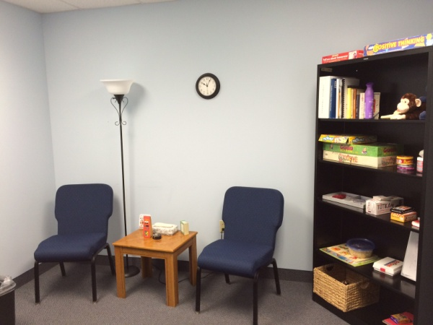

## Administrative Policies and Procedures

During orientation to the site, interns are provided with a policies and procedures training manual that contains important policies and information for the internship program as well as for the center. Included in the training manual are due process and grievance policies concerning identification and resolution of problems arising during the internship year. The interns are also privided with a clinical orientation handbook, which deliniates additional information regarding the site and center regulations (e.g., dress code, copies of the APA ethics code).

**CLINICAL EXPERIENCE**

The internship is comprised of 2000 hours, which is a 40-45 hour per week experience for each intern and *does require the flexibility and the willingness to work some evenings and weekends*. Interns are expected to spend approximately twenty hours per week in direct contact with clients.

During the training year, interns provide a range of outpatient services to diverse cultural, ethnic, and socioeconomic groups utilizing various treatment modalities. Experiences in assessment, intervention and consultation occur with the following populations: children, adolescents, adults, older adults, couples, families, and individuals diagnosed with serious and non-serious mental illness, with physical and developmental disabilities and with addictions. Interns also administer psychological and vocational testing batteries, and prepare written reports which include Head Start consultation, observation and evaluation. Treatment, consultation and outreach occur in the community (various agencies and schools), outpatient and possibly residential settings.

While training, interns are exposed to clinical specialty areas such as EMDR, PCIT, Hypnosis, and to senior staff with expertise in ASD, DID, pediatric mental health and complex trauma. Interns also provide supervision to master's-level clinicians by direct monitoring of their work products (e.g., progress notes and treatment plans). Interns further have the opportunity to work on special projects such as grant writing, improving testing batteries, research, enhancing progress monitoring, and leading staff trainings (e.g., effective treatment planning). In support of these experiences, ample training and supervision is provided: didactics, psychiatrist-led treatment teams, and individual and group supervision occur weekly; in-house trainings, conferences, and bi-monthly outpatient education is also provided. Program supervisors solicit frequent feedback on formative and summative bases, particularly related to needed program modifications required to meet specific learning objectives n

Within these various arenas interns are encouraged to examine the factors that affect their theoretical approach to treatment and consultation and are also encouraged to further expand their clinical repertoire and understanding of mental health.

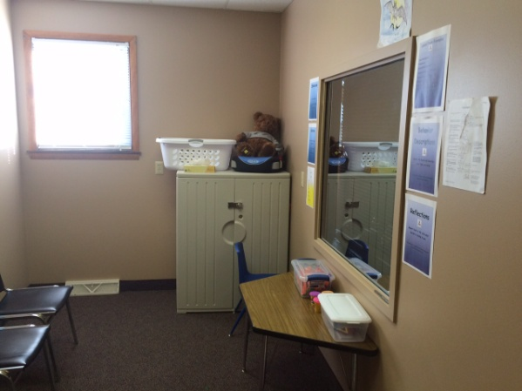

PCIT Offices – Greenville Site

**Primary Rotation**

Community Counseling Center

Community Counseling Center offers many opportunities for interns to train in a number of programs and activities based on interest and availability. Interns will be able to provide Mental Health Assessments, Psychological Evaluations (general and OVR), Individual or Marital/Couples/Family therapy, and co-facilitation of outpatient Mental Health and Drug & Alcohol groups. Opportunities to design a curriculum for group facilitation are also available. Additionally, interns may participate in the provision of community-based services through School-Based treatment and evaluation if they elect to do so. They will conduct assessment interviews and hone diagnostic skills through administering various testing batteries and completing professionally written reports. West Central Center for the Deaf (WCCD) is a direct service and consultative center. Interns with appropriate training and credentials may provide community-based mental health services to the deaf and hard of hearing throughout west central Pennsylvania. Other minor rotations may include experiences in psychiatric rehabilitation services and/or residential housing programs. CCC also provides consultation services to The Mercer County Head Start Program whereby interns may provide assessment or educational services. Interns are expected to facilitate several training experiences for CCC staff, and to provide clinical supervision and oversight for other clinicians. The Interns will receive weekly individual and group supervision to support them in their various clinical rotations and roles, and to enhance their ethical and professional development, along with their multicultural awareness. They will also participate in bi-weekly consultation and multidisciplinary treatment teams facilitated by the Medical Director or a number of other resident psychiatrists. For general information regarding Community Counseling Center please visit our web site at [www.cccmer.org](http://www.cccmer.org). *Please note this link does not provide further information specifically regarding the internship program.*

**Schedule**

A typical week for the intern may include the following:

Direct clinical hours (therapy or testing) - 20-25 hours

Supervision, Individual - 2 hours

Supervision, Group - 2 hours

Training activities - 4-6 hours

Consultation - 2 hours

Peer contact - 2 hours

Intern’s supervision of others - 2 hours

Administrative - 2-4 hours

**DIDACTIC TRAINING**

Interns receive training in a broad range of topics relevant to the practice of psychology and community mental health. Topics include clinical, ethical, and social-cultural issues of interest. Trainings are conducted in both formal and informal settings at the agency, and formal seminars/trainings outside of the agencies (i.e., professional conferences offering CEU credits). Presenters can include professionals from CCC or professionals from within the community representing various social service, or private practice agencies. Informal training experiences also occur through observation, attendance at grand-rounds, treatment team meetings, assigned readings, etc. As part of their experience the interns are also expected to provide trainings to other staff members based on their dissertation topic, or clinical topics of interest.

Didactic trainings are developmentally structured throughout the year, and reflect the intern’s current training needs. Training seminars at the onset of the internship year are generally centered on orientation to the agency and agency policies, preparatory seminars to assist interns in preparing for clinical practice at the agency, and educational seminars (e.g., OVR assessment, diagnosis and diagnostic procedures). As the internship year progresses, didactic trainings become more specific and are targeted at developmentally appropriate clinical issues, such as multidisciplinary practice, ethical practice, cultural competency in rural mental health, and leadership seminars. Interns are encouraged to provide input into areas of clinical interest, and efforts are made to accommodate their requests.

**SUPERVISION**

Licensed psychologists employed by Community Counseling Center provide individual clinical supervision on a weekly basis. A minimum of two hours per week is set aside for individual supervision; however supervisors are available throughout the week for consultation as needed. Supervision may take place in the office and may include the use of audio, or videotape. Live supervision may also be utilized within the community or office setting. Ancillary supervision by clinicians within various departments in which the intern is working may also be provided.

Group supervision is provided on a weekly basis as well. During this time the supervision focuses on specific cases or clinical issues and professional identity development. Interns may present difficult cases for discussion, and obtain and provide constructive feedback. Interns should be prepared to present cases utilizing various theoretical perspectives. Weekly group supervision also serves to encourage and support peer interactions among the interns.

Additionally, individual and group supervision is utilized to further the intern’s knowledge and skills in formal psychological assessment. A variety of assessment instruments are reviewed during the course of the year including cognitive, personality, projective measures and neuropsychological screening instruments. Assigned psychological assessments will be discussed with regard to interpretation and integration of the test data, as well as cultural, legal, and ethical factors.

**EVALUATION PROCEDURES**

During the first month of the internship each intern is formally evaluated with regard to his or her level of skill, knowledge, and ability. Specific goals or objectives for the internship are identified in a collaborative manner by the supervisor and the intern. These goals and objectives are then monitored throughout the internship experience. Interns are expected to reach these goals (competencies), along with the program goals, as outcome measures for the successful completion of the internship year with no lower than a rating of “3” (acceptable) in any domain.

Supervisors maintain weekly contact via telephone, email, or in person, in order to discuss matters related to the interns, their progress and challenges. Formal written evaluations are completed at 6 and at 12 months. Informal feedback is provided throughout the year during individual supervision. Interns will also evaluate the supervisors at 6 and at 12 months.

## REQUIREMENTS FOR COMPLETION

***To successfully complete the internship program, interns must achieve the following requirements:***

1. An intern must be in "good standing" and may not be on “probationary status.”
2. By the conclusion of the training year, an intern must achieve a majority of ratings of "3" on the final Evaluation of Intern Performance, indicating that an intern requires minimal supervision and is exhibiting competency at the level expected at the conclusion of the training year. Furthermore, an intern must not receive any ratings of "1" or "2" on the final Evaluation of Intern Performance.
3. The intern must have completed the requisite number of clinical hours during the course of the year.
4. Interns must complete a minimum of two psychological assessments (either through the Office of Vocational Rehabilitation, or in-house/external psychological testing). The intern must demonstrate competency in the administration, scoring, interpretation, and report writing of the assessment, as measured by a rating of at least “3” on the final Evaluation of Intern Performance. This indicates that an intern requires minimal supervision for the interpretation of the instrument and is demonstrating skill at the level expected at the conclusion of the training year.
5. Interns must obtain a score of at least 80% correct on at least 75% of the didactic seminar post-tests. Should an intern not receive each post-test following 2 supervision seminars. Should an intern not receive a score of at least 80%, he or she intern will be required to complete remedial reading and retake the post-tests until supervision competency is met.

**PRIMARY CLINICAL FACULTY**

*Lisa A. Phillips, Ph.D.,* earned her doctorate degree in clinical psychology in 2006 from Duquesne University in Pittsburgh, PA. The year prior, Dr. Phillips was a member of the first intern class to complete their doctoral training at the Community Counseling Center in Hermitage, PA. In 2008, she became a licensed psychologist in the state of PA, and completed the necessary coursework to become a Board Certified Behavior Analyst-Doctoral level (BCBA-D) as well. Dr. Phillips clinically supervises children and family service programs and oversees other BCBA-candidates who mainly work with children diagnosed with Autistic Spectrum Disorders. The majority of her professional experiences have been in the areas of children and family services in outpatient and community settings, clinical supervision, and training and development.

*Sue-Ellen Brown, Psy.D.,* received a Psychology Doctorate degree in clinical psychology in 1986 from Central Michigan University and completed her internship at the Philadelphia Psychiatric Center in Philadelphia, PA in 1984. She practiced clinical psychology in Michigan and Pennsylvania from 1980 to 1999 and worked extensively with victims of childhood abuse. She was an assistant professor of psychology at the University of Sciences in Philadelphia for six years, and from 1999 to 2010, Dr. Brown worked as an assistant professor at the Tuskegee University School of Veterinary Medicine’s Center for the Study of Human-Animal Interdependent Relationships. She also did research and published on the human-animal bond including the application of self psychology to companion animals, ethnic variations in pet attachment and dissociation and pet attachment. She is certified in hypnosis through the America Society of Clinical Hypnosis, and three of her dogs are certified therapy dogs with Therapy Dogs International. Her dog, Callie, accompanies her to work each day.

*Michael Greisler, Psy.D*, is a licensed psychologist and licensed clinical social worker (LCSW). He completed his doctoral studies at Carlow University in Pittsburgh, PA. His dissertation is entitled: Mothers and their Children with High Functioning Children with Autism Spectrum Disorder: Perceptions of Relational Victimization. For six years, therapist worked exclusively with children and teens diagnosed with Autism Spectrum Disorder (ASD) at the Watson Institute. Dr. Greisler completed his pre-doctoral internship and post-doctoral residency at Community Counseling Center (CCC). Currently, he is an outpatient clinical supervisor at CCC. Within CCC’s psychology internship program, Dr. Greisler provides didactics, supervision of psychological testing, and informal supervision of cases for current doctoral interns. In direct treatment Dr. Greisler works with all manner of clients (e.g., children to elderly) with various diagnoses, including ASD and psychotic disorders.

Krista M. Laux, Psy.D, licensed psychologist, completed her doctoral studies at and received her degree in Counseling Psychology from Chatham University in Pittsburgh, PA. Her dissertation was titled “The Effects of Social Activism on Well-Being: A Feminist Identity Perspective.” Dr. Laux completed her pre-doctoral internship and post-doctoral residency at Community Counseling Center (CCC). As a doctoral resident, Dr. Laux served as an ancillary supervisor for the internship program and functioned as the lead consultant with the Head Start program in Mercer County, PA. Presently, Dr. Laux provides didactics, supervision of psychological assessment and report writing, and group supervision to interns and clinical staff at CCC. She also provides individual, family, and couples psychotherapy to a wide range of clients at both the Hermitage and Greenville sites and is an outpatient clinical supervisor at CCC.

## Applicants and Application Process

Accepting Applicants: Yes

Month, Day, Year: 12/1/15

Time Zone: Eastern

This program uses the AAPI: Yes

On-Site Interview: Required

Interview Notification Date: 12/15/15

Tentative Interview Dates: 1/8/16, 1/15/16, 1/22/16, 1/29/16

Interview Process Description: Interviews are held on Fridays during the month of January, and typically commence on the first or second Friday.  The interview is standardized across applicants and is approximately one hour in length.  It is a group interview format with both psychologists, pet therapy dog (Callie), interns, psychology residents, and frequently various outpatient supervisors and the CEO are present.

How to obtain application information: Email the Program

Preferred method of contacting the program: Email

Applicant Requirements:

US Residency: Yes

Canadian Residency: No

Master’s Degree Required: No

Comprehensive Exams Passed: Yes, by start of internship

Dissertation Proposal Approved: Yes, by start of internship

Dissertation Completed: Preferred

Dissertation Defended: No

Minimum Number of APPI Intervention Hours: 300

Minimum Number of APPI Assessment Hours: 150

Minimum Number of Years of Grad Training Required: 3

Applicants Welcome from these Program Types:

Clinical Psychology: Preferred Counseling Psychology: Acceptable

APA-Accredited: Preferred Non-Accredited/CPA-Accredited: Acceptable

Ph.D.: Preferred Psy.D.: Preferred

**APPLICATION PROCEDURE**

The following information should be submitted by December 1, 2015:

1. Complete AAPI application, which is available online through the APPIC web site at: [www.appic.org](http://www.appic.org).
2. Work sample of a testing report with all identifying information redacted

Applications should be processed in accordance with APPIC expectations. The Online APPI must be utilized by all applicants. The Community Counseling Center Psychology Internship adheres to APPIC Match polices and participates in the APPIC Match.

Any direct mailings should be sent to:

Lisa A. Phillips, Ph.D.

Director of Training

Community Counseling Center Psychology Internship

Community Counseling Center

2201 East State Street

Hermitage, PA 16148

(724) 981-7141 x 115

[lphillips@cccmer.org](mailto:lphillips@cccmer.org)

Completed applications will be reviewed by the internship committee and by current interns. Qualified applicants with training needs and goals that are consistent with Community Counseling Center’s training model will be invited to interview for a position. In very rare cases, those unable to schedule an on-site interview may be interviewed via Skype.

*This internship site agrees to abide by the APPIC policy that no person at this training facility will solicit, accept, or use any ranking-related information from any intern applicant. This internship site abides by all APPIC regulations. A copy of regulations regarding Uniform Notification is available at:* <http://www.appic.org/about/2_3_5_about_policies_and_procedures_match.html>

**ADDITIONAL INFORMATION**

The internship year will commence on July 1, 2016 and will end on June 30, 2017. The internship experience provides 2080 hours of supervised clinical training. The internship stipend is $18,720.00. Individual medical insurance is available with employee contribution of $23.60 per pay. Twelve paid holidays and 40 hours of personal paid time off (PTO) are provided. In addition to the annual paid time off, interns may be granted authorized absence for approved training activities and conferences, as well as for their dissertation defense.

**ABOUT THE AREA**



Mercer County Courthouse

The western Pennsylvania area offers a small town atmosphere, yet is conveniently located between several large metropolitan areas. Pittsburgh, Cleveland, and Erie are all within a short driving distance and provide wonderful opportunities for enrichment. There is direct and easy access to Interstates 80 and 79 linking Mercer County with shopping, cultural, and sporting events in these cities.

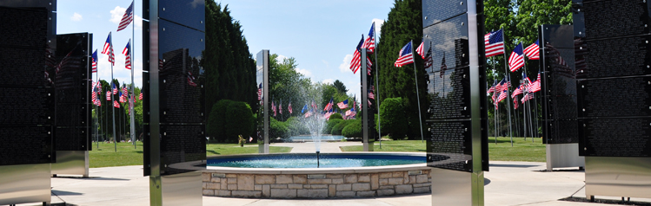

Avenue of Flags

There are a variety of activities available within the area and stunning natural beauty. The Allegheny Mountains provide scenic richness throughout the year but are never more spectacular than in the fall with the change of seasons. Winter allows for snow sports and there are many ski resorts within driving distance. Spring and summer months provide a temperate climate. Swimming, biking, hiking and other outdoor activities are popular in the area.



Buhl Park

Historically this area was a major contributor to the nation’s steel industry. Some of the large steel mills have ceased operations however many remain active. The economic base has expanded to include light industry, hi-tech manufacturing, the service industry, and tourism. The average family income is approximately $30,000.

The cost-of-living also makes western Pennsylvania an attractive place to reside. Real estate and housing are available far below the national average. The average cost of a home is $58,000, and average rent is $500.

**APPENDIX A**

**COMMUNITY COUNSELING CENTER**

**PSYCHOLOGY INTERNSHIP PROGRAM POLICY AND PROCEDURE**

**________________________________________________________________**

**HUMAN RESOURCES PERSONNEL DUE PROCESS PROCEDURE**

**POLICY:**

Disciplinary action shall be taken against an intern only when all other means of correcting a situation, including have failed. The following measures will be used when appropriate and shall be documented in the intern’s personnel file, with the knowledge of the intern. The intern has the right to appeal or grieve the action taken. The grievance procedure is described in a separate policy. A copy of the due process policy is given to interns during their orientation to the program.

**PURPOSE OF THIS DOCUMENT:**

1. This document provides interns with a definition of problematic performance and provides an explicit step-by-step overview of the due process procedure. Note that both the grievance procedure and remediation plan described in the due process procedure are outlined in separate documents (name documents here).

**DEFINING PROBLEMATIC PERFORMANCE:**

1. Problematic performance is defined in this setting as being based on the professional judgment of supervisors, and includes the supervisor’s perception that an intern’s clinical performance, professional relationships, or professional behavior is being negatively affected by the trainee’s behavior, attitude, or other characteristics. More specifically, rankings of one (1) or two (2) on the intern’s quarterly evaluations, with no demonstration of improvement between evaluations, is qualified as problematic performance. Moreover, supervisors may observe or recognize problematic performance in the interim between evaluations and choose to intercede immediately, if they determine using professional judgment that the behavior is serious enough to warrant intervention.

**METHODS OF IDENTIFYING PROBLEMATIC PERFORMANCE:**

1. The below methods are in accordance with the *Guidelines for Clinical Supervision in Health Service Psychology* (APA, 2014).
   1. Supervisors “give precedence to protecting the well-being of clients/patients above the training of the supervisee. When supervisees display problems of professional competence decisions made and actions taken by supervisors in response to supervisees’ competence problems should be completed in a timely manner” (pp. 22).
   2. Methods of managing competence and behavioral problems begin with supervisory contract, which outlines the competencies and behaviors required for satisfactory performance during the internship year. Additionally, evaluative and remediation procedures are included in the contract.
   3. Supervisors utilize an ongoing evaluative process to assess a supervisee’s functioning in all domains of the internship. Supervisors take into account several factors when assessing for problematic behavior, including:
      1. Distinctions between normative development and significant competence problems
      2. Intersections between diversity and cultural issues and competence
      3. Feedback from multiple sources (other supervisors, consultation, direct observation of supervisee’s work)
   4. When supervisors determine that a supervisee is exhibiting significant problematic performance, they have an ethical duty to address this with the supervisor and to develop a remediation plan if necessary, while maintaining sensitivity to the supervisory relationship and individual differences. This is conducted by following the below due process procedure.
      1. The Supervisor will closely monitor and document the progress of the supervisee as he or she takes steps to resolve the problem.

**PROCEDURE:**

1. At the onset of the internship program, expectations for professional and clinical functioning are reviewed, and the educational nature of the training program is made clear for each trainee. Each trainee is provided with concise and stepwise information regarding the evaluation process of the program and the policies and actions regarding making decisions about problematic performance and/or conduct. As a training program, both interns and supervisors recognize that areas of weakness and “growth edges” are a natural part of the trainee’s development, and will be treated as such.
2. Prior to the implementation of disciplinary action, remediation of minor deficiencies and problematic areas is provided through the course of normal didactic training and supervisory interaction with the intern’s primary and secondary supervisors. This may consist of didactic instruction, modeling of appropriate therapeutic techniques, providing readings and literature to the intern, using real-time supervision of sessions, and assigning cases to help provide the intern with more training opportunities in the identified area of deficit. These aspects are also targeted as domains of continued growth will be included in the interns’ midterm evaluation as an area of focus for the second half of the training year. As informal feedback and evaluation will be provided regularly (at least monthly) in supervision, any areas of major deficiencies will likely be identified early in the training program, and will be remediated using the below due process guidelines if informal remediation is not effective. Each remediation plan will include the following details:
   1. A description of the intern’s unsatisfactory performance or problematic behaviors
   2. Recommended actions needed from the intern to correct the identified problems
   3. Supportive intervention/modifications made to the intern’s training program (e.g., increase supervision, change focus of supervision, require coursework or readings, reduce caseload and recommend personal therapy)
   4. A time line for correcting the problem
   5. The action to be taken if the problem is not corrected.

If the remediation plan is not successful, the training director may work with the intern, as well as with the other training psychologists, to either modify the remediation plan or implement a probation period.

1. Disciplinary notes are written by the intern’s direct supervisor, or any internship program supervisor or executive staff member for the following reasons: if an intern receives an “unacceptable” rating in any major category of evaluation; if a staff member or another intern has concerns about the intern’s behavior (i.e., ethical violations, professional incompetence); if the professional judgment of staff members identity problematic behaviors related to personal conduct (i.e., inability to control personal stress, strong emotional reactions, and/or psychological dysfunction which interfere with professional functioning).
2. A disciplinary note will become part of the intern’s file. The intern must sign the note as verification that he/she acknowledges that he/she has received it. An intern does not have to agree with any action taken on a note placed in his/her file and he/she has a right to respond to the matter addressed in the note. The intern’s response will be attached to the note and will also become a part of the intern’s permanent personnel record.

3.The following procedure for disciplinary action shall be followed:

a. First Offense - After the supervisor discusses the problem with

the intern, he/she will receive a documented oral warning. The intern will work with the supervisor to create a formal, written remediation plan (form in Appendix _ ) and will agree to a specified time-frame for satisfactorily resolving of the disciplinarily offense(s).

b. Second Offense - The intern receives a documented written warning and the intern’s school is notified with a documented oral warning. The graduate program’s training director is encouraged to provide input, if appropriate, regarding how to address the difficulty.

c. Third Offense - The intern is suspended up to three (3) days without pay and the intern’s school is notified in writing.

d. Fourth Offense - The intern is terminated from employment. The intern’s school is notified in writing. APPIC or any other accrediting bodies (i.e. APA or

CPA) are notified in writing.

4. The above procedure does not negate the right of the Community Counseling Center administration to suspend or dismiss an employee under the termination policy.

5. If at any time an intern disagrees with the aforementioned process or decision made by the supervisor/administration, he or she can utilize the grievance procedure (under separate document) to appeal the decision.

**___________________________**

**AUTHORIZED BY**

**DIRECTOR OF TRAINING**

**Reviewed/Revised Date 08/24/15**

**APPENDIX B**

**COMMUNITY COUNSELING CENTER**

**PSYCHOLOGY INTERN PROGRAM POLICY AND PROCEDURE**

**_**

**HUMAN RESOURCES INTERN GRIEVANCE PERSONNEL**

**POLICY:**

A grievance is a dispute concerning the interpretation, application, or alleged violation of the Internship Agreement and will occur only after the intern has met with his/her supervisor at a “Meet and Discuss” Session to try and resolve the issue at hand. A copy of the grievance policy is given to interns during their orientation to the program.

**PROCEDURE:**

1. **First Step** - Immediate Supervisor. Grievance Procedure: The intern will put forth the grievance in writing on the “Meet and Discuss Form” to his or her supervisor. This shall occur if a serious concern arises regarding the program, or within fourteen (14) calendar days of an alleged violation. The supervisor will set up a meeting time with the intern to attempt to resolve the dispute to the satisfaction of the intern and management. The supervisor will have seven (7) calendar days from the date of the meeting to put in writing on the “Meet and Discuss Form” his/her decision from the meeting, and return it to the intern. A copy of said decision will also be forwarded to the internship Training Director.
2. **Second Step**- Training Director. Appeal Process: If the intern is not satisfied with the decision made by his/her immediate supervisor written on the “Meet and Discuss Form,” the intern will forward the “Meet and Discuss Form” to the Internship Training Director along with a written formal grievance asking the Training Director to consider the intern’s appeal. The appeal must be presented to the Training Director within fourteen calendar (14) days of the intern receiving the “Meet and Discuss Form” from his/her supervisor. The Training Director shall then set up a meeting with the intern to discuss the information submitted to him/her. An attempt to resolve the dispute to the satisfaction of the intern will occur and the Training Director will give the intern a written decision within fourteen (14) calendar days following the meeting. A copy of said decision will also be placed in the intern’s personnel file. In cases where the Immediate Supervisor is also the Training Director this step will be skipped and the intern will proceed to step three.
3. **Third Step** – Chief Executive Officer. Arbitration: If the intern is not satisfied with the disposition of his/her grievance at the second step, he/she will write out and deliver to the Chief Executive Officer of Community Counseling Center a request for arbitration. This must be done within twenty-one (21) calendar days after receiving the written decision at the second step from the Training Director. Upon receipt of a notice requesting an arbitration, the parties shall meet at a mutually agreed upon time to discuss the situation and attempt to resolve all issues.

___________________________

**AUTHORIZED BY**

**DIRECTOR OF TRAINING**

**Reviewed/Revised Date 08/01/15**