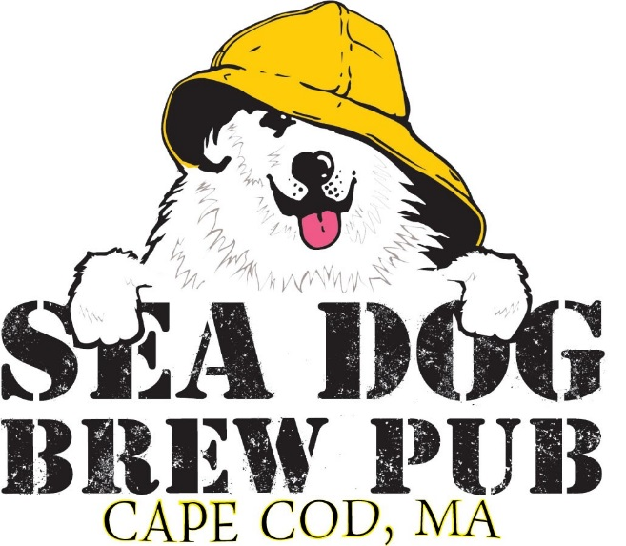

Thank you for choosing Sea Dog Brew Pub for your upcoming event!
As a locally owned and operated restaurant, we take the utmost pride in our guest satisfaction. From the freshest seafood to our certified Angus beef, here at Sea Dog we expect nothing but the best for our guests.

We offer several options and accommodations for your gathering. Our Front room can seat 50 people. Cocktail parties and standing room events can hold up to 75 people more. We try to accommodate all our guests’ special requests, please feel free to ask if we can help you in any way possible.

We can also customize a menu or package that will make your event day special.
All packages come with complimentary cookies and brownies
Or
Chef’s dessert of the day

All Packages include Tax and Gratuity

Brunch Buffet
20 per person
Assorted Breakfast Pastries
Fruit Platter
Scrambled Eggs
Apple Smoked Bacon
Maple Sausage
Crispy Home Fries
French Toast or Buttermilk Pancakes
Add
Chicken Marsala 4
Baked Local Cod 6
Stuffed Shrimp 8
Apple Cranberry Stuffed Chicken 4

Carving Stations
150 Chef’s Fee
Slow Roasted Prime Rib (minimum 30 people) 15
With horseradish sauce, red wine demi glaze and dinner rolls
Herb Crusted Turkey Breast (minimum 25 people) 9
With cranberry compote, turkey sauce and dinner rolls
Roasted Brown Sugar Glazed Ham (minimum 30 people) 9
With honey Dijon glaze and dinner rolls
Pork Loin (minimum 20 people) 9
With caramel apple sauce, grain mustard pork sauce and dinner rolls

Omelet Station 8
Farm fresh vegetables, ham, bacon, linguica and assorted cheeses

Waffle Bar 6
Freshly made buttermilk waffles served with fresh strawberries, blueberries, raspberries, blackberries, Chantilly cream and pure maple syrup

Continental Breakfast
10 per person
Assorted Breakfast pastries
Baked brie with fruit jams
Tropical fruit platter
Smoked salmon with condiments and bagel chips
Coffee tea and juice station
Add
Scrambled eggs 4
Bacon 3
Sausage 3

Hot Hors D’oeuvres per piece
Seafood Stuffed Mushrooms 3
Petite Meatball Pomodoro 3
Cheese Arancini ala Vodka 3
Panko Chicken Tenders 2
Thai Chicken Satay 3
Teriyaki Beef Satay 3
Chicken Wings 2
Buffalo Chicken Dip Cups 3
Coconut Crusted Shrimp 3
Mini Lump Crab Cakes 3
Scallop wrapped in Bacon 4
Clams Casinos 4
Mini Stuffed Quahogs 4
Beef Wellington 4
Petite Lobster Mac & Cheese Cups 4
Fish & Chips Cones 4
Lobster Bisque Soup Shouter with Sherry Cream 4
Vegetable Spring Rolls – vegetarian 3

Cold Hors D’oeuvres per piece
Prosciutto and Melon 3
Smoked Salmon on Toast 4
Sliced Tenderloin Crostini 4
Shrimp Cocktail 4
Petite Lobster Rolls 5
Summer Heirloom Gazpacho Shooter 3
Smoked Salmon Crostini 4
Tomato Mozzarella Skewers – vegetarian 3
Tomato & Fresh Mozzarella Bruschetta vegan 3
Ahi Tuna Snapps 4
Asian Vegetable Cucumber Cup – Vegan 3
Herb Goat Cheese Crostini 3

Raw Bar /per piece
(150 charge for Shucker)
Shrimp Cocktail 4
Chatham Oysters 3
Chatham Little Neck Clams 3
Lobster Claws 5
King Crab Legs 7
Scallops in half Shell 6

Stationary Displays
Fresh Fruit Display 4
Cheese Board 3
Assorted imported and local cheese with mixed berries, grapes and crackers
Vegetable Crudités 3
Raw Seasonal Vegetables with 2 dipping sauces
Smoked Salmon 6

Sandwich Platters
Assorted Meat Wraps 6
Assorted Vegetarian Wraps 5
Tuna Salad Finger Rolls 4
Chicken Salad Finger Rolls 4
Harvest Chicken Salad Wraps 6
Mini Croissant Lobster Salad Rolls 8
Tea Sandwiches assorted 3
All platters come with choice of pasta, potato, mixed green house salad

Barney’s
35 per person including Tax and Gratuity
Platted or Buffet style
(Minimum 10 People)

Salad
(please choose one)
Tavern Salad
Caesar Salad

Entrées
(please choose two)
Slow Roasted Sliced Prime Rib
Chicken Saltimbocca
Stuffed Local Sole (mixed seafood stuffing)
Seafood Casserole (mixed seafood with lobster bisque)
Grilled Pork Tender Loin with Pineapple Relish
Chicken Marsala

Sides
(Please choose two)
Roasted potato
Potato Gratin
Mashed Yukon Gold Potato
Saffron Rice
Sautéed Vegetable Medley

Dessert
Please choose one
Apple Crisp
Key Lime Pie
New York Cheesecake

Bass Hole
38 per person including Tax and Gratuity
Platted or Buffet style

First Course
(please choose one)
Homemade New England Clam Chowder
House Salad
Traditional Caesar Salad

Second Course
(please choose two)
Pan Roasted Boneless Half Chicken
Herb Crusted Atlantic salmon
Grilled Pork Tenderloin with Apple Cranberry Chutney
Chicken Marsala
Sautéed Chicken Breast with portabella mushrooms, cherry tomatoes in a marsala wine sauce
(please choose two sides)
Asparagus
Roasted Potatoes with garlic herb butter
Red Bliss Mashed Potato
Saffron Rice
Glazed Baby Carrots
Broccoli with garlic butter

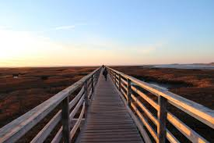

Mayflower Beach
45 per person Tax and Gratuity
Platted or Buffet style

First Course
(please choose one)
Homemade New England Clam Chowder
House Salad
Traditional Caesar Salad

Second Course
(Please choose two)
Beef Wellington
Filet mignon with Dijon mustard
Potato Crusted Cod Loin
Sweet potato crusted local cod loin with lime butter broth
Boneless Half Chicken
Pan roasted boneless half chicken with thyme au jus
Seared Scallops
Pan seared jumbo sea scallops with champagne beurre blanc

Sides
(Please choose two)
Broccolini
White Asparagus
Maple Baby Carrots
Jasmine Rice
Sweet Pea Risotto
Twice Baked Potato

All packages come with complimentary cookies and brownies
Or
Chef’s dessert of the day

We can also customize a menu or package that will make your event day special.
Pricing based on menu selections.

