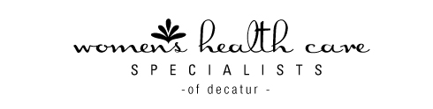

3D/4D ULTRASOUND

We are pleased to provide the opportunity to preserve special memories of your pregnancy with 3D/4D ultrasound images, best obtained between 26 and 30 weeks gestation. This is a great way to remember your experience, and it makes a wonderful baby shower gift if someone is looking for ideas!

- Package price of $85.00 (twins $125), paid at the time of services, no refunds.
- Scanning will take about 20 minutes.
- All ultrasounds must be scheduled in advance.
- You will receive 3 black & white 3D pictures and a DVD with multiple still and video images.
- If for any reason, adequate images can’t be obtained (for example, due to baby’s position), you will have the opportunity to return for one additional session at no charge. (Sorry, but no refunds for uncooperative babies! The second scan must be completed before 33 weeks gestation.)

I have read and agree to the above guidelines for 3D/4D Ultrasound.

Print Name:_________________________________________________

Signature:___________________________________________________

Date:___________________________________

